Raoula Joseph Bourge
September 2, 1921 – December 23, 2008

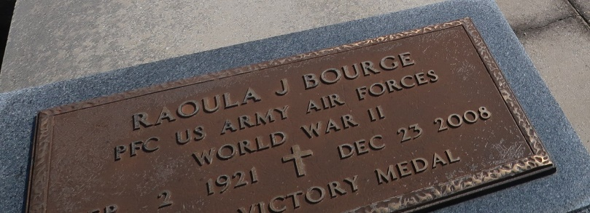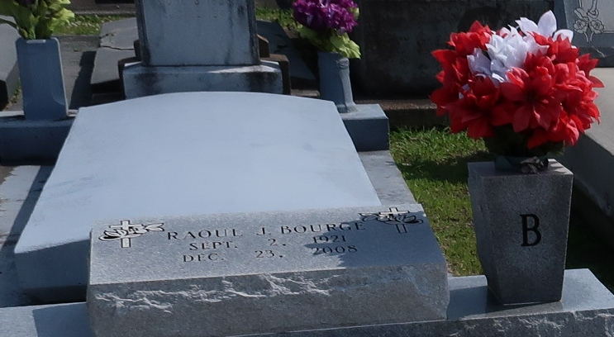

Raoula Joseph "Ray" Bourge, 87, passed away on Tuesday, Dec. 23, 2008, at 2 p.m. He was a resident and native of Napoleonville and a veteran of the U.S. Air Force.
He is survived by his wife, June Bell Bourge; sons, Joseph and wife Walda and William "Billy" Bourge and wife Karen; daughters, Rita Pfister and husband Roland and Diedra "Dee Dee" Minvielle and husband Kim; stepsons, Melvin Wheat and wife Melanie, Tim Wheat and wife Tammy, Hank Wheat and wife Sonia and Charles Wheat; stepdaughters, Paulette Bentley, Linda Wheat, Joan Rogers and husband Billy and Bobbie St. Pierre and husband Glynn; 28 grandchildren and 19 great-grandchildren.
He was preceded in death by his parents, Henry and Clara Lauland Bourge; stepson, Jerry Cooper; brothers, Henry Jr. and Lauland; half brother, Howard Lopez; and sister, Eva Folse.
Visitation at Rose Lynn Funeral Services in Lutcher on Friday, Dec. 26, from 5 p.m. to 9 p.m. Visitation continues at the funeral home on Saturday from 8 a.m. to 10:30 a.m. Mass of Christian Burial at St. Joseph Catholic Church in Paulina at 11 a.m. Saturday. Interment in the church cemetery. .
The Advocate, Baton Rouge, Louisiana
December 25, 2008

