Leola (Oubre) Bourgeois
February 14, 1929 - August 18, 2024
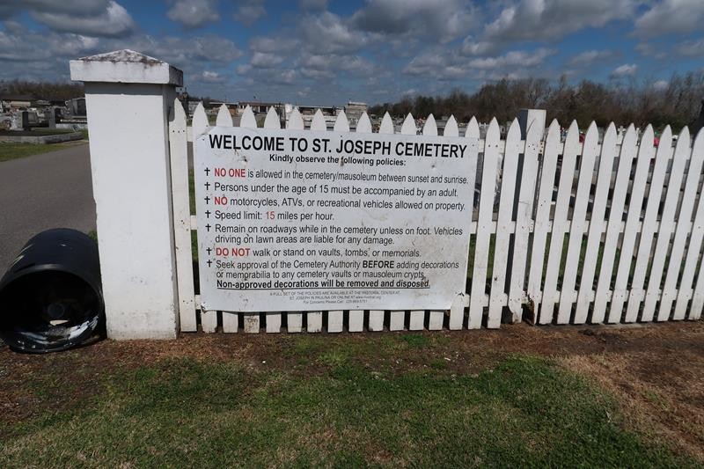

Leola Oubre Bourgeois passed away on Sunday, August 18, 2024 at the age of 95. She was born in Vacherie, LA and was a resident of Lutcher, LA.
Beloved wife of the late Lester Roy Bourgeois. Loving mother of Geralyn Cox (Chris), Marlene Roussel, Leonard Bourgeois (Sharon) and Lorraine Medlin (Marty). Grandmother of Brandi, Lindsey, Benjamin, Leah, Rachelle and the late Rhonda. Great grandmother of Ryder, Tyler, Skyler, Bryleigh, Joshua, Lucas, Jacob and James. Daughter of the late Amilcar Oubre and Anicia Luquette Oubre. Sister of the late Harriett Dupepe (the late Clarence) and Doris Mitchell (the late Fred). Also survived by nieces and nephews.
Relatives and friends are invited to attend the Visitation and Funeral Mass at St. Joseph Catholic Church, 2130 Rectory St., Paulina on Friday, August 23, 2024. Visitation will be held at the church from 9:00 a.m. to 11:00 a.m. followed by a Funeral Mass at 11:00 a.m. Interment in St. Joseph Cemetery, Paulina, LA.
Rose Lynn Funeral Home, Lutcher, Louisiana
August 20, 2024

