Scott Bourgeois
February 1, 1966 – September 25, 2021

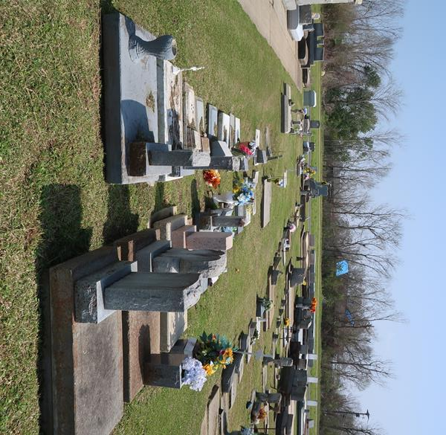

Scott “Fuzzy” Bourgeois was born on February 1, 1966 in Lutcher, LA and was a lifelong resident of Paulina, LA. He passed away on September 25, 2021 at the age of 55.
Fuzzy was very talented and enjoyed woodworking, etching glass, and drawing. He was an outdoorsman and loved to hunt and fish. He enjoyed spending time with his family and friends, watching LSU and Saints football games, and singing karaoke.
Fuzzy is survived by his wife of 33 years, Sally Meades Bourgeois; son, Nicholas Bourgeois; daughters, Erica Bourgeois (Mike), Jenna Bourgeois (Tyler), and Amber Bourgeois (William); grandchildren, Cecilia Beech, Koi Kinler, Nathan Boudreaux, and Teigan Ast; mother, Brenda St. Pierre Bourgeois; siblings, Cathy “LaLa” Bourgeois, Jimmy Bourgeois (Debbie), Barry Bourgeois, Danny Joe Bourgeois (Laurie), Corey Bourgeois (Tanya); mother-in-law, Marie Meades; sister-in-law, Wanda Dauzat (Steve); brother-in-law, Flavious “Boo” Meades III (Marlene); as well as a host of nieces and nephews.
He is preceded in death by his father, Oliver “Poochie” Bourgeois, Jr.; grandparents, Oliver and Thelma Bourgeois and Laury and Florence St. Pierre; father-in-law, Flavious Meades, Jr.; and uncles, Gary St. Pierre and Ray St. Pierre.
A visitation will be held at Rose Lynn Funeral Home in Lutcher, LA on Saturday, October 2, 2021 from 9:00 AM to 11:00 AM followed by a religious service. Interment will take place at a later date.
In lieu of flowers, monetary donations can be made to Rose Lynn Funeral Home to help with funeral expenses.
Rose Lynn Funeral Home, Lutcher, Louisiana

