Tessa (Hatfield) Bourgeois
May 6, 1923 – February 8, 2014

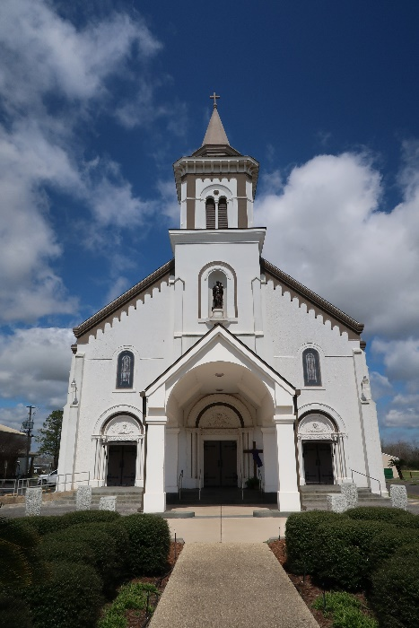

Tessie Hatfield Bourgeois, 90, native of Texas and resident of St James parish, passed away on Saturday February 8, 2014, peacefully at her home.
She was born to the late Freddie and Sarah Pharris Hatfield on May 6, 1923 in Anderson, TX. She married the late Wilfred Bourgeois on October 9, 1943. She is survived by 8 children: Shirley and David Braun, Steve and Brenda Bourgeois, Glen and Cheryl Bourgeois, Linda and John Wells, Edmond and Barbara Bourgeois, Lucille Bourgeois, Thelma Bourgeois and Joe Cortez, and Jerry Bourgeois. She is also survived by 16 grandchildren, 21 great grandchildren, and 1 great great grandchild.
She is preceded in death by her parents, husband, 3 children: Elaine Bourgeois, David Bourgeois, and Martin Bourgeois, and her siblings: CJ, Willie, Wayne, Maggie, Dorothy, and Lillie. Tessie was a loving wife, mother, and grandmother; she will be greatly missed by her family.
Visitation will be Thursday, February 13, 2014 from 9am until Mass of Christian Burial, at 11:00 a.m. at St James Catholic Church. Burial will be in St James Cemetery, under the direction of Ourso Funeral Home, Donaldsonville.

The Advocate, Baton Rouge, Louisiana
Feb. 11 to Feb. 12, 2014

