Lebo Joseph Cantillo

September 29, 1934 – May 4, 2013

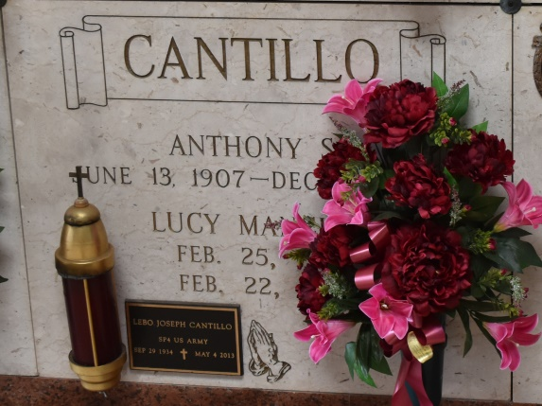 

Lebo Cantillo, age 78, was born on September 29, 1934 and passed away on Saturday, May 4, 2013. He was a native of Gramercy, LA and a resident of Southeast Louisiana War Veterans Home in Reserve, LA.

He is survived by his daughters: Vanessa Beiriger, Jackie McCaskill and husband Wade. He is also survived by his siblings: Anthony Cantillo and wife Barbara; Mary Ann Brady and husband "P.J."; Rocky Cantillo and wife Tina; and a step-daughter, Rhonda Duhe. He leaves behind his grandchildren: Donovan and fiancée Alicia, Brynne, Jordyn, Garrison, Peyton, Payne, and Jake; and great-grandchildren: Croy, Braysen and Makaya. He was preceded in death by his parents: Anthony Cantillo and Lucy Mancuso Cantillo; a step-son, Rocky Duhe; brothers: Victor and James Cantillo; sister-in-law, Avis Cantillo; and a nephew, Michael Cantillo.

Visitation will be on Thursday, May 9, 2013 from 8:30 a.m. until 10:30 a.m. at Rose Lynn Funeral Services, 1870 Cabanose Ave., Lutcher, LA followed by a Mass of Christian Burial at Sacred Heart Catholic Church in Gramercy at 11:00 a.m. A private burial will be at a later date. To sign and view the family guestbook, please visit [www.roselynnfuneralhome.com.](http://www.roselynnfuneralhome.com/)

Published in The Advocate (Baton Rouge, LA) from May 7 to May 9, 2013.