Christopher John Cox

July 8, 1931 – May 15, 2000

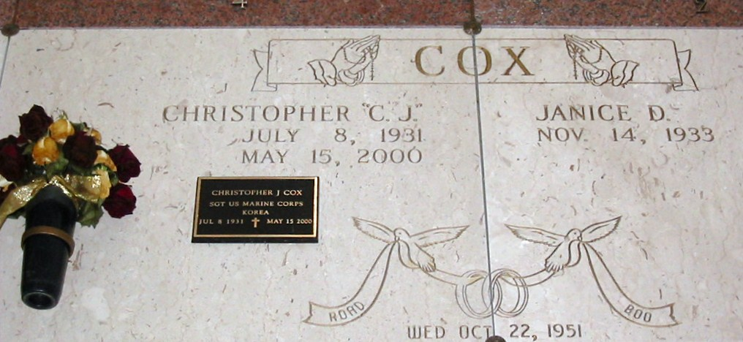

Photo by Bobby

Christopher John Cox, Sr. Died On Monday, May 15, 2000. Aged 68 Years. A Native Of Reserve And A Resident Of Lutcher, La. Retired From Kaiser Aluminum With 26 Years Of Service And A Member Of Luther Gramercy Veterans Of Foreign Wars Post 5852.

Beloved Husband Of Janice Duhe Cox. Father And Father-In-Law Of Susan C. And Roger Louque And Christopher, Jr. And Geralyn B. Cox. Grandfather Of Jennifer Louque, Brandi Cox, Travis Louque, Marcie Louque, Lindsey Cox And Erin Louque. Great Grandfather Of Ryder Cantillo And Caden Louque. Son Of The Late John And Ezilda Troxler Cox. Brother Of Henry, Jerry, Donald And John L. Cox And The Late Kathryn Louque And Vernon Cox.

Relatives And Friends Of The Family Are Invited To Attend Funeral Services. A Mass Of Christian Burial Will Be Celebrated On Thursday, May 18, 2000 At 11:00 A.M. At St. Joseph Catholic Church In Paulina. Friends May Call At H.C. Alexander Funeral Home Of Lutcher, 2208 Jefferson Hwy., Lutcher, La On Wednesday Evening From 6 Until 9:30 Pm And On Thursday Morning From 9:45 To 10:45 Am. Entombment In St. Joseph Mausoleum.

Unknown source