# Janice (Duhe) Cox

November 14, 1933 - May 19, 2023

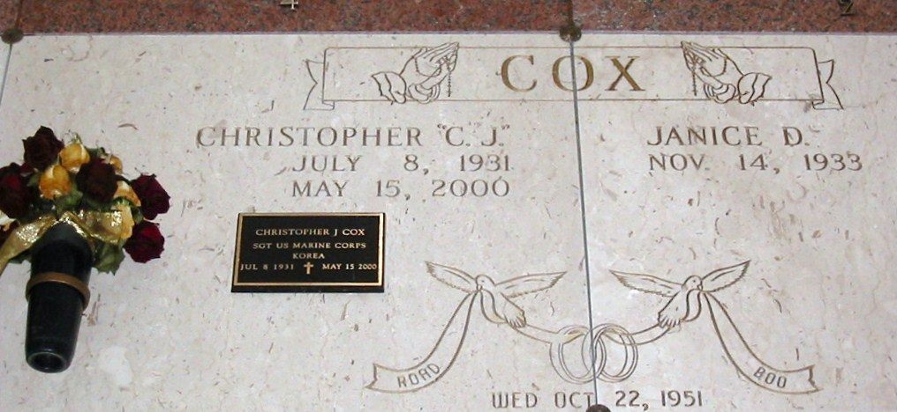

Photo by Bobby

Janice Duhe Cox a lifelong resident of Lutcher passed away on Friday May 19, 2023 at the age of 89.

Beloved wife of 48 years to the late Christopher “CJ” Cox. Loving mother Susan Louque (Roger), Christopher Cox, Jr (Geralyn). Grandmother of Jennifer Veron (Darren Meliet), Travis Louque (Tara), Marcie Tolito (Jerry), Erin Louque (Luke Young), Brandi Credidio (Joey) and Lindsey Whitener (Josh). Great-grandmother of 19. Daughter of the late Tristan and Martha Duhe. Sister of the late Marguerite Barrios, Mazie Martin, Rosemary Matherne, Rita Veron,  Marie Elise Blankenship, Robert Duhe, Larry Duhe, Richard Duhe, Maurice Duhe, and Thomas Duhe.

Janice's love for cooking, watching LSU football, crocheting, and dancing brought joy to her family and friends.

Relatives and friends are invited to attend the Visitation and Funeral Mass at St. Joseph Catholic Church, 2130 Rectory St., Paulina, LA on Tuesday, May 23, 2023. Visitation will be held at the church from 9:00 a.m. to 11:00 a.m. followed by a Funeral Mass at 11:00 a.m. Interment in St. Joseph Cemetery, Paulina, LA. Arrangements by Rose Lynn Funeral Home. To view or sign the online guest book, please visit www.roselynnfuneralhome.com

Rose Lynn Funeral Home, Lutcher, Louisiana

5/20/2023