Nolan Joseph Deroche

December 5, 1921 – October 29, 2009

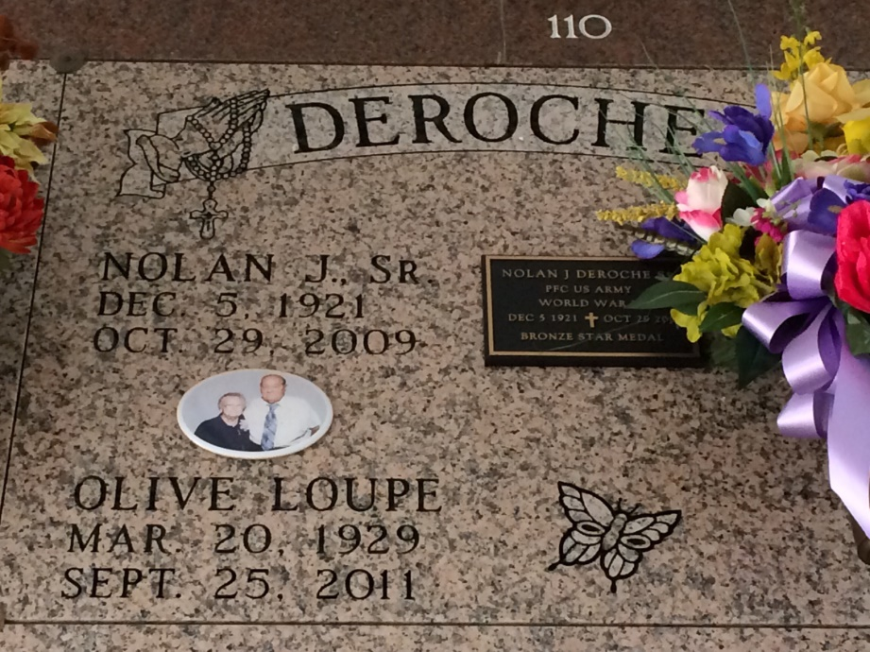

Photo by Kerry Keller

Nolan Joseph Deroche Sr. died at age 87 on Thursday, Oct. 29, 2009, at 4:45 p.m. at his home in Gramercy. He was born in New Orleans on Dec. 5, 1921. He retired from Colonial Sugars in 1987 after 34 years of service.

He is survived by his wife of 62 years, Olive Loupe Deroche; a daughter and son-in-law, Karen and Paul Remondet; a son and daughter-in-law, Nolan and Kathy Deroche; five grandchildren, Chad Remondet, Juanita and husband Webb McDonald, Matthew and wife Haley Deroche, Sarah Deroche and Chris Deroche and close friend Jan Bevil; and brothers, Arand Deroche, and Roy and wife Julie Deroche. He is also survived by six great-grandchildren, Skye Deroche, Emily, Andrew and Erica McDonald, Beau Deroche and Hunter Deroche; as well as a brother-in-law, Alvin and wife Gloria Loupe; and a host of nieces and nephews.

He was preceded in death by his father and mother, Theodore Deroche and Louisiana Dupre Deroche; a daughter who died at birth; brothers, Roland Deroche, Sheffard Deroche and Joseph "J.W." Deroche; and a sister, Shirly Coulon.

Special thanks to Carol Taylor, River Region Hospice (especially Mary, Ann Marie, Cindy, Ed and Charles), the Rev. Vincent Dufrense and Irene Poche.

Visitation at Rose Lynn Funeral Services, 1870 Cabanose Ave., Lutcher, on Sunday, Nov. 1, from 6 p.m. to 9 p.m. Visitation resumes at the funeral home on Monday, Nov. 2, from 8 a.m. to 10:30 a.m. followed by a Mass of Christian Burial at 11 a.m. at Sacred Heart Catholic Church in Gramercy. Entombment will follow in St. Joseph Mausoleum, Paulina. To sign and view the family guestbook online, please visit www.roselynnfuneral hom.com.

Published by The Advocate (Baton Rouge, Louisiana)

from Oct. 31 to Nov. 1, 2009.