Olive (Loupe) Deroche

March 20, 1929 – September 25, 2011

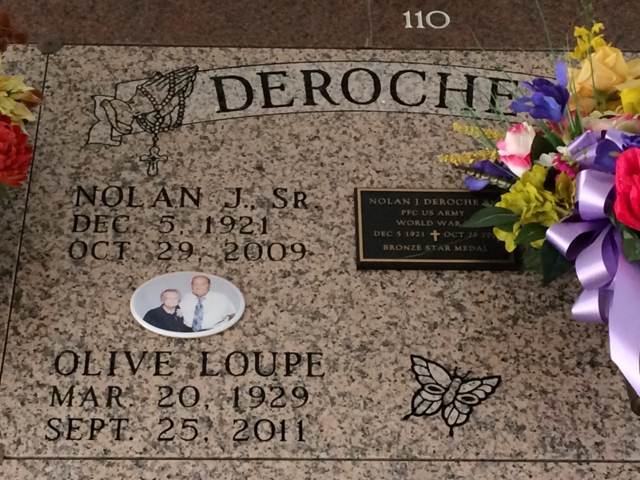

Photo by Kerry Keller

Olive Loupe Deroche passed away at home Sunday, Sept. 25, 2011. Olive was 82 years young and a native and resident of Gramercy. Olive was a very loving and special person. She loved her family very much. Olive would do anything to help someone. She loved to talk to anybody in person or on the phone.

She was the wife of the late Nolan Deroche Sr. Daughter of the late George Loupe and Palmyre Badeaux Loupe. She was the mother of Karen Remondet and husband Paul Remondet, and Nolan Deroche Jr. and wife Kathleen. She was the grandmother of Chad Remondet, Juanita McDonald and husband Webb, Matthew Deroche and wife Haley, Sarah Deroche, and Chris. She was the great-grandmother of Skye Deroche, Emily, Andrew, and Erica McDonald, Beau Deroche and Hunter. She was the sister of Alvin P. Loupe and wife Gloria Torres Loupe. Also survived by sisters-in-law, Julie Kilburn Deroche and Betty Deroche; brother-in-law, Arand Deroche; a host of nieces and nephews; and special friend, Jan Bevil.

Special thanks to Mark and Gail Roussel, Irene and Shannon Poche, Carol Bourgeois, C.J. and Nelwyn Mancuso, and River Ridge Hospice. Pallbearers will be Chad Remondet, Matthew Deroche, Webb McDonald, George Loupe, Jeff Loupe, and Lenny Loupe. Honorary pallbearers are Andrew McDonald and Beau Deroche.

Visitation at Rose Lynn Funeral Home on Wednesday, Sept. 28, from 5 p.m. to 9 p.m. Visitation resumes at the funeral home on Thursday, Sept. 29, from 8 a.m. to 10:30 a.m., followed by a Mass of Christian Burial at Sacred Heart Catholic Church in Gramercy at 11 a.m. Entombment in St. Joseph Mausoleum, Paulina. Arrangements by Rose Lynn Funeral Services, 1870 Cabanose Ave., Lutcher. To sign and view the family guestbook, please visit www.roselynnfuneral[home.com](http://home.com/).

Published by The Advocate (Baton Rouge, Louisiana)

from Sep. 27 to Sep. 28, 2011.