Percy Paul ‘Pep’ Detillier

April 14, 1934 – January 14, 2011

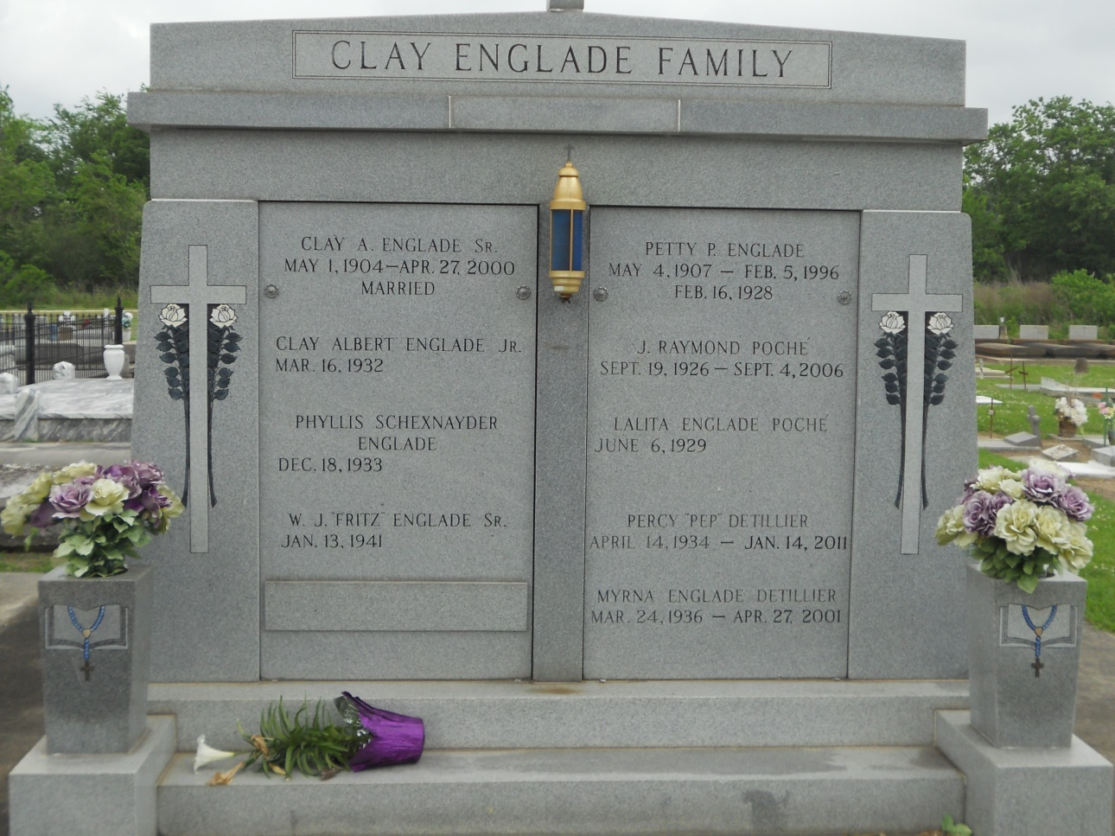

Photo by Team TLo

Percy “Pep” Detillier, 78, passed away at 8:55 p.m. Friday, Jan. 14, 2011 at his home in Lutcher, with his loving family at his side.  
 Funeral services were held Jan. 20 at St. Joseph Catholic Church, 2130 Rectory St. in Paulina, with interment in the church cemetery.  
 He was a loving father of Alan Detillier, Bret Detillier, Petty Detillier Pollet and husband, Peter, Lisa Detillier Hymel and husband, Dennis; devoted grandfather of Ryan Detillier, Holly Detillier, Rene Pollet Buchanon, Rachel Pollet Miles, Jared Pollet, Lindsay Hymel Cambre, and Dennis Hymel Jr.; loving great-grandfather of Che’Lynn Detillier, Seth, Kayleigh , and Gavin Buchanon, Hannah Miles, and Cruz Cambre; and brother of Dudley Detillier and wife, Gloria, and Elsie Levet and husband, John.  
 He was the beloved husband of the late Myrna Englade Detillier; son of the late Alcee and Marguerite Arabie Detillier; and brother of the late Thelma DeJean, Shirley Borrello, Jeannette, Charles, Archie, and Lynn Detillier.  
 Pep retired after 43 years of service with Shell Oil Refinery in Norco, as a supervisor. He was an avid RV enthusiast and the past president of Lutcher/Gramercy Jaycees, past director of the St. James Parish Sugar Queen Pageant, a former usher for St. Joseph Catholic Church in Paulina, and past member of Lutcher Volunteer Fire Department, St. James Parish Historical Society and Lutcher Planning Committee.  
 H.C. Alexander Funeral Home of Lutcher is in charge of arrangements.

Daily Comet, Lafourche Parish, Louisiana

January 21, 2011