James L. Duhon Sr.

March 13, 1910 - August 8, 2004

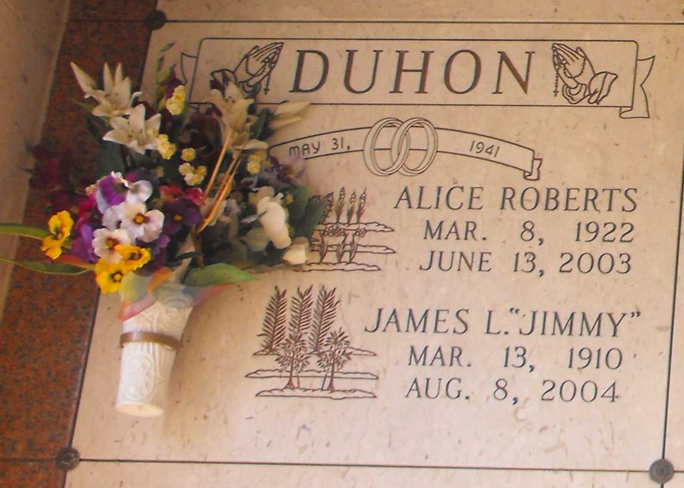

Phot by Mary Agnes Hammett

"JIMMY" passed away at the age of 94. He was the beloved husband of the late Alice Roberts Duhon.  
 Survived by five daughters and sons-in-law, Viola and Louis Segari, Metairie, Delphine and Chris Gremillion, Alexandria, Paula and Harris Cassagne, Reserve, Louise and Len Baird, Huntsville, Ala., and Theresa and Marcel Jacob, LaPlace; and four sons and daughters-in-law, James, Jr. and Norma and Ronald and Susan, all of LaPlace, Leonard and Rhonda, Prairieville, and Melvin and Erleen, Baton Rouge. Also survived by a sister, Ruby Duhon, California; 25 grandchildren and 25 great-grandchildren.

Unknown source