Zula (Singletary) Dupuy
May 24, 1922 - September 5, 2023

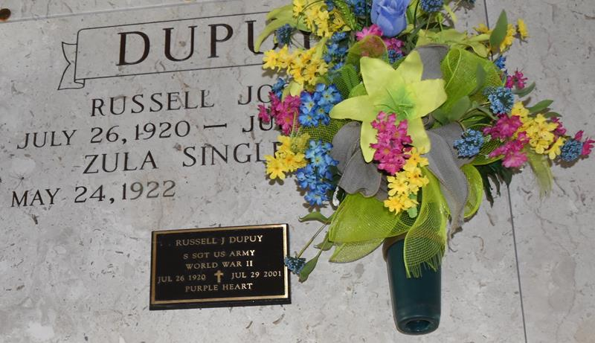

Zula Singletary Dupuy passed away on Tuesday, September 5, 2023 at the age of 101. She was born in Brignac, LA and a resident of Lutcher, LA. Zula was a proud member of the Lutcher United Methodist Church.
Beloved wife of the late Russell Dupuy. Loving mother of James Dupuy (Florence), Timothy Dupuy, Lynnette Dupuy Hidalgo (Bryant), Patricia Dupuy Rizzuto (the late Frank), Mary K. Chambless (Phillip), and the late Gwendolyn Dupuy Rizzuto (the late J.B), and the late Patrick Dupuy. Grandmother of Stephen Dupuy (Jackie), Melissa Elson (Michael), Lynnette Whitney (Jeff), Alison Poche (Marty), Seth Rizzuto, Daniel Dupuy (Sarah), Jessica Dupuy, Courtney Johnson (Lyle), Jennifer Hidalgo, Jeremy Hidalgo, Landon Dupuy (Ashley), Chad Chambless, Chet Chambless (Amber), and Frank Rizzuto, Jr. (Cathy). Great grandmother of John and Vivi Dupuy, Mary Elizabeth, Emily, and Charlie Elson, Kymber Lawver (Mitch), Jacie and Rhett Whitney, Payton, Kristen, and Zack Poche, Gabriel and Luke Rizzuto, Hazel and expected baby sister Dupuy, Russell Dupuy, Lathan Williams, Logan and Gabe Chambless, Gage and Brodie Chambless, Ashley Roper, and Jacob Rizzuto.
Daughter of the late Tom Watson Singletary and Mary Stevens Singletary. Sister of James Singletary (the late Shirley), Kathleen Thompson (Clyde), and the late Fuqua Singletary, Willery Capron, Molly Prince, Lowell Singletary, and Paul Singletary, Sr. Also survived by numerous nieces, nephews and friends.
Relatives and friends are invited to attend the Visitation and Funeral Service at Rose Lynn Funeral Home, 1870 Cabanose Ave., Lutcher, LA on Friday, September 8, 2023. Visitation from 11:00 a.m. to 1:00 p.m. followed by a Funeral Service at 1:00 p.m. Interment in St. Joseph Cemetery, Paulina, LA. In lieu of flowers, please donate to the charity of your choice.
Rose Lynn Funeral Home, Lutcher, Louisiana
September 6, 2023

