Clay Albert Englade, Jr.

March 16, 1932 – April 9, 2017

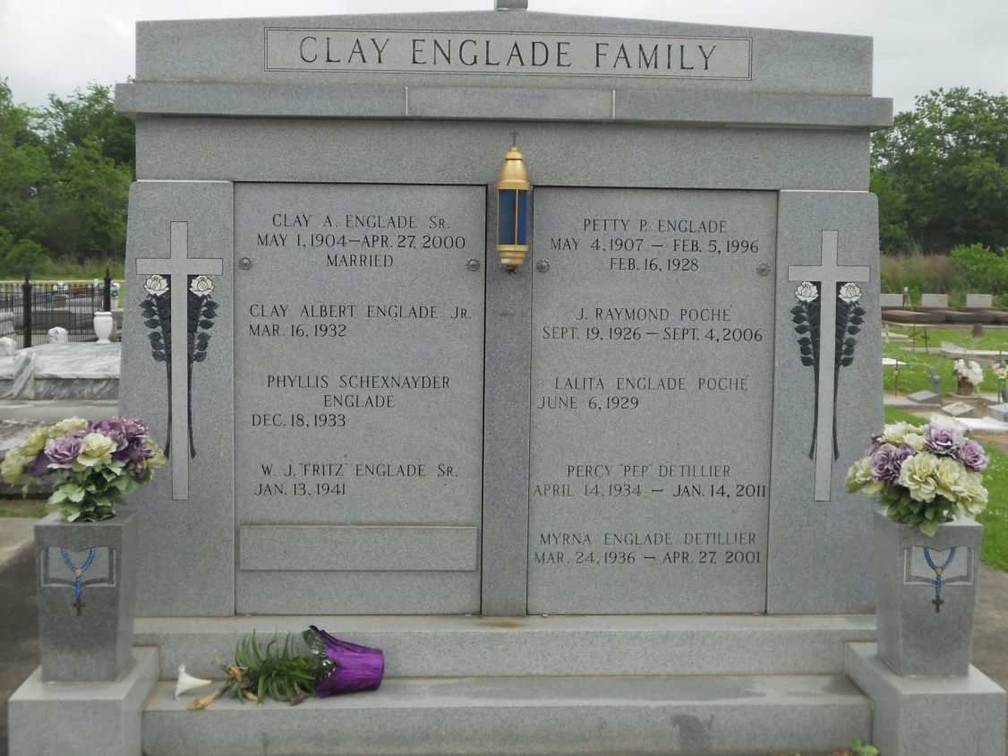

Photo by Team TLo

Clay “Albert” Englade, Jr., age 85, was born on March 16, 1932 and passed away on April 9, 2017 surrounded by his loving family.  He is survived by his wife of 60 years, Phyllis Schexnayder Englade; children:  Allison Blank (Roy, Jr.), Stephanie Jallans (Gary), and Larry H. Englade II (Jan).  He is also survived by his four grandchildren:  Roy “Trey” Blank, III, Jeremy Jallans (Kristy), Trevor Englade, and Gavin Englade and 2 great-grandchildren, Tyler Jallans, and Emma Jallans. He is preceded in death by his parents, Clay Englade, Sr. and Petty Perdomo and a son, Clay A. Englade, III.   
 He was a graduate of Lutcher High School Class of 1951 as a 4 year letterman in varsity football, a graduate of LSU with a degree in industrial engineering, a member of Phi Kappa Theta fraternity, served in the US Army during the Korean Conflict, a member of the VFW Post 5852, a lifelong member of the Knights of Columbus, a past president of the Lutcher-Gramercy Jaycees, and one of the first Eucharistic Ministers of St. Joseph Catholic Church. He was a retiree of E. I. DuPont of LaPlace, LA after 20 years of service.  
 He loved spending time with his beautiful wife, and children. He was Pops to his four grandsons and 2 great grandchildren who were the love of his life.  He was an avid LSU Tiger fan, loved to travel, and work in his workshops and enjoyed working with the youth of St. James Parish.   
 A visitation in his honor will be on Tuesday, April 18, 2017 at Rose Lynn Funeral Services, 1870 Cabanose Ave., Lutcher, LA from 9:00 a.m. until 10:30 a.m. followed by a Mass of Christian Burial at 11:00 a.m. at the Lutcher Chapel. Interment will follow at St. Joseph Cemetery in Paulina, LA.  To sign and view the family guestbook, please visit [www.roselynnfuneralhome.com](http://www.roselynnfuneralhome.com)

Published online by the Rose Lynn Funeral Home, Lutcher, Louisiana