Phyllis Fay (Schexnayder) Englade

December 18, 1933 – February 20, 2020

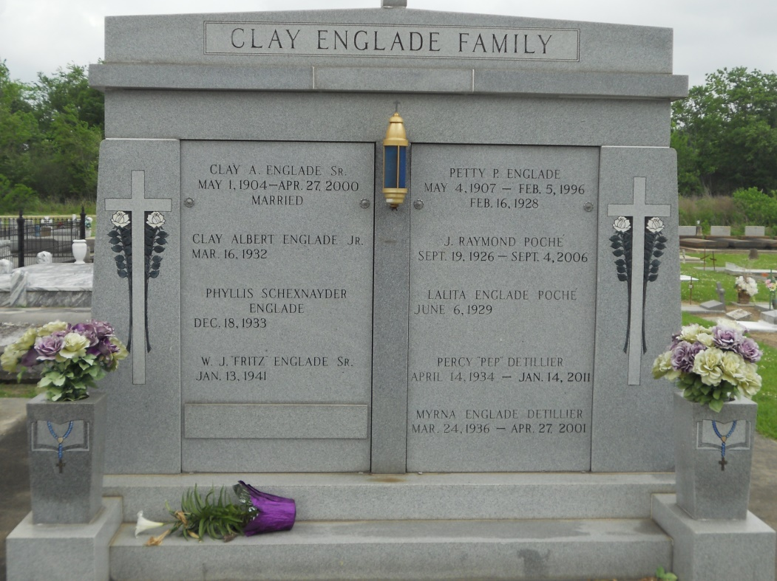

Photo by Team TLo

Phyllis Fay Schexnayder Englade, a resident of Lutcher, passed away on Thursday, February 20, 2020 at the age of 86.

     She is survived by her children, Larry H. Englade II (Jan), Stephanie Jallans (Gary) and Allison Blank (Roy); grandchildren, Trevor Englade, Gavin Englade, Jeremy Jallans (Kristy) and Roy “Trey” Blank III; great-grandchildren, Tyler Jallans and Emma Jallans; and siblings, Dolores Masson, Mary Scallan, Elwood Schexnayder, Ray Schexnayder, Paul Schexnayder and Rogwell Schexnayder.

     She is preceded in death by her beloved husband of 60 years, Clay A. Englade Jr.; son, Clay A. Englade III; parents, Edgar Schexnayder and Noela Fredric Schexnayder; and siblings, Margery Groteguth, Grace Schexnayder, Marlyn Staley and Gloria Schexnayder.

     A visitation in her honor will be held on Friday, February 28, 2020 at Rose Lynn Funeral Services from 9:00 AM until 10:30 AM.  A Mass of Christian Burial will take place at St. Joseph Church at 11:00 AM.  Interment will follow in the church cemetery.

     Phyllis treasured her family and adored her grandchildren and great-grandchildren.  She was an artist on both canvas and in the kitchen, often feeding her family gumbo and pecan pie.  She and her beloved husband enjoyed traveling and dancing.  Phyllis was an avid LSU fan.  She, her husband and family could often be found tailgating at Tiger Stadium.  She also enjoyed gardening and birdwatching.  She will be greatly missed by her family, friends and anyone who had the pleasure of meeting her.

     The family would like to thank Ormond Nursing Center and staff, The Pink Ladies and St. Catherine’s Hospice for their loving care and compassion.

Published online by Rose Lynn Funeral Home, Lutcher, Louisiana