Gayle (Denny) Faucheux

August 24, 1936 – October 13, 2014

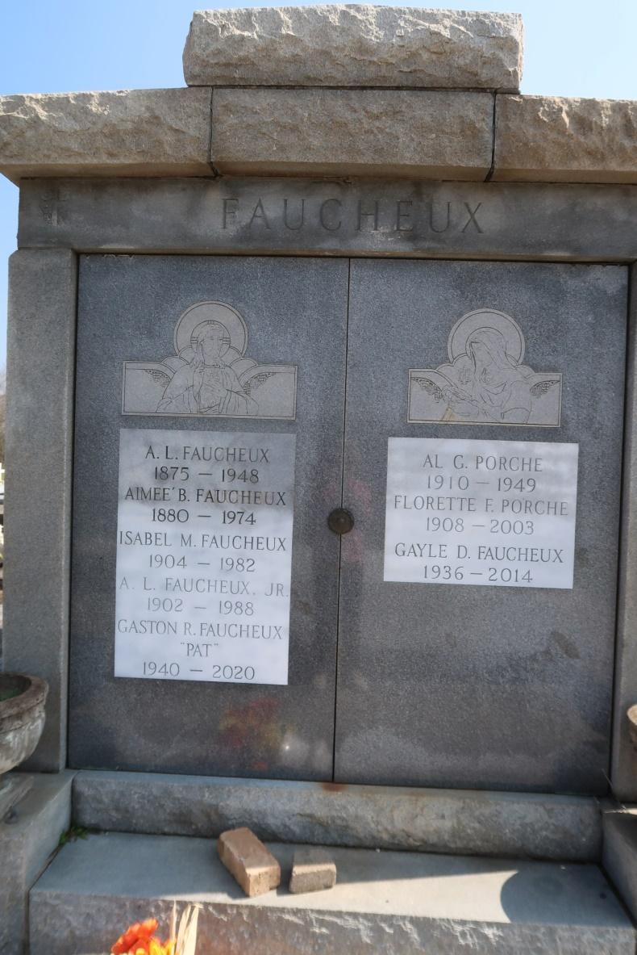

Gayle Denny Faucheux passed away peacefully on October 13, 2014. Gayle was born in Kansas City, Kansas, on August 24, 1936. She was the daughter of William Denny (deceased) and Joan Hagemann Denny (deceased). She is survived by her husband, Donald Faucheux and brothers: Warren Denny and David Denny as well as a sister, Junie Kay Digiovanni. Services will be private. In lieu of flowers, donations to the American Cancer Society or Alzheimer's Association preferred. Rose Lynn Funeral Services, 1870 Cabanose Ave., is in charge of the arrangements.

Advocate, The (Baton Rouge, LA)

Monday, October 13, 2014