Mary Ann (Millet) Forsyth
January 9, 1947 – August 9, 2024

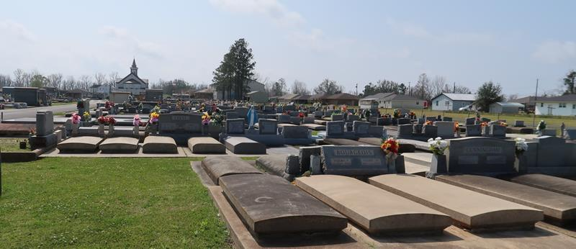

Mary Ann Millet Forsyth was born on January 9th, 1947, and passed away peacefully on Friday, August 9th, 2024 at the age of 77. She was a native of Garyville and lifelong resident of Lutcher, Louisiana.
Devoted mother of Theresa Louque (Steven), Tammy Jacob (Byron), Tina Abadie, and Leonard Forsyth (Brandy). Loving grandmother of Jordan Duhon (Kelcie), Cody Duhon, Emily Jacob (Evan Mullins), Justin Jacob, Joshua Abadie, Olivia Forsyth, and Mia Forsyth. Great grandmother to Truett, Hollis, and Quincy Duhon, and Locklen Jacob.
Mary Ann is survived by her siblings David Millet (Judy), James Millet, Larry Millet (Susan), and Judy Brewer (Purnell). Also survived by numerous nieces, nephews, and cousins.
She is proceeded in death by her husband, Alvin J. Forsyth Jr. (Tuddy), parents, Junius and Josephine (Vicknair) Millet, in laws, Alvin J. Forsyth Sr. and Hazel (Heltz) Forsyth, siblings Raymond Millet, and Junius “Jr.” Millet.
Mary Ann touched the lives of so many as she was a dedicated childcare provider for 54 years. In her free time she enjoyed gardening, baking, and listening to music. Her and her husband also enjoyed numerous outdoor activities such as fishing and crabbing. Her children and grandchildren were her entire life, and she will be missed very dearly.
A special thank you to St. Joseph Hospice in Baton Rouge in providing exceptional care on her last days of life.
Relatives and friends are invited to attend the visitation at St. Joseph Catholic Church, 2130 Rectory St., Paulina on Friday, August 16th, 2024 from 9:00 am to 11:00 am followed by a funeral mass at 11:00 am. Interment in St. Joseph Cemetery, Paulina, LA.

Rose Lynn Funeral Home, Lutcher, Louisiana
August 11, 2024

