Evelyn Marianne (Bourgeois) Guerra

March 5, 1909 - April 16, 1976

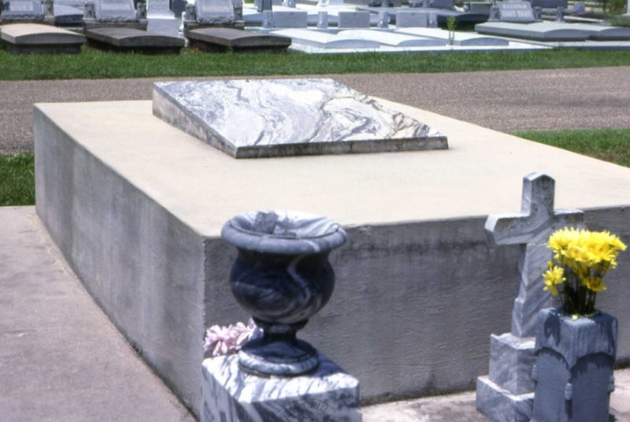

Aloysius A. Bourgeois Family Tomb

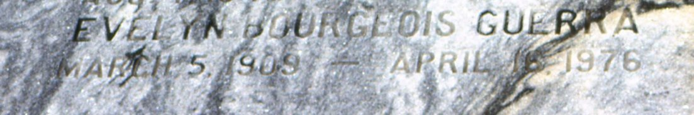

Photos by Dwayne Montz

Mrs. Evelyn Bourgeois Snipes.

Died Friday, April 16, 1976, at 11:30 a.m. at St Francis Hospital, San Francisco, Calif. She was 67, a native of Lutcher and a resident of San Francisco for 38 years. Visiting at Alexander Funeral Home, Lutcher, from 6 to 10 p.m. Wednesday and 8:30 to 10:15 a.m. Thursday. Religious services at St Joseph Catholic Church, Paulina, at 10:30 a.m. Thursday, with burial in church cemetery. Survived by two sons, Albert H. Guerra, US Navy, Reston, Va, Theodore Badal, Eldridge, Cal; three sisters, Mrs. Joseph (Inez) Babin, Lutcher, Mrs. E. P. (Emma) Feucht, Mrs. Roy (Camille) Montz, both of LaPlace; two brothers, Herbert Bourgeois, Baton Rouge, Adolph Bourgeois, Port Sulphur; two grandchildren. Preceded in death by her first husband, Albert Guerra; her second husband, Theodore Badal; her parents, Mr. and Mrs. Aloysius Bourgeois; two brothers, Nolan and Junius Bourgeois; one sister, Mrs. Yvonne Foret.

OBITUARY, The Morning Advocate, Baton Rouge, Louisiana; 21 Apr 1976, p 6

Contributed by Dwayne Montz