Deloris (Washington) Johnson
Unknown – August 21, 2018

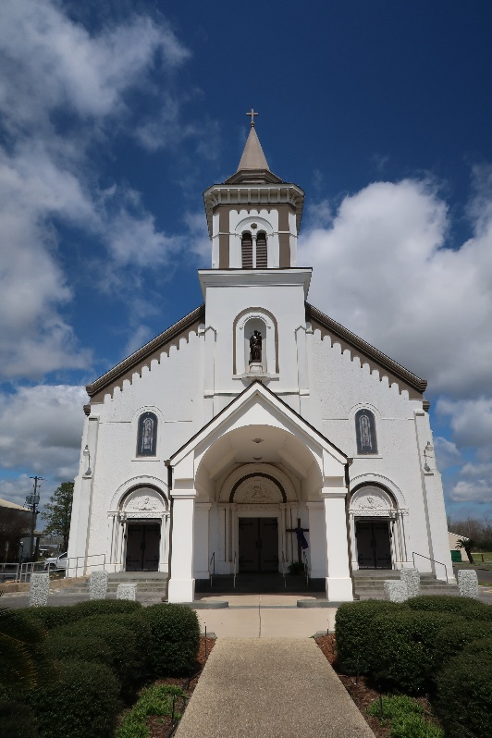

Doloris W. Johnson peacefully crossed over on August 21, 2018.
Daughter of the late Wilbert Washington, Sr. and Evelyn Kennard. Wife of the late Oscar Johnson, Sr. Mother of Cynthia DeRouesselle, Oscar (Catherine) Johnson, Jr., Patricia (Paul) Hayes, Christopher Johnson Sr., Janet (Aaron) McKinley, and Charlene (Michael). Parker. Doloris is also survived by 1 Sister Selina McNealy, 1 Sister in law, grandchildren, great grandchild, and a host of nieces, nephews, relatives and friends.
Home going service will be held on Saturday August 25, 2018 at First Community Antioch Church 11802 HWY 3125 Lutcher, La 70071 at 11:00 am Rev. Ferdinand Gaines, Jr. Pastor Officiating. Visitation will be at the church from 9 am until service time. Interment in St. Joseph Cemetery Paulina, La. Professional Services entrusted to the caring staff Hobson Brown Funeral Home, 134 Daisy St., Garyville, La 70051, (985) 535-2516.
The New Orleans Advocate, Louisiana
Aug. 23, 2018

