Isaac Michael Johnson
1942 – April 30, 2016

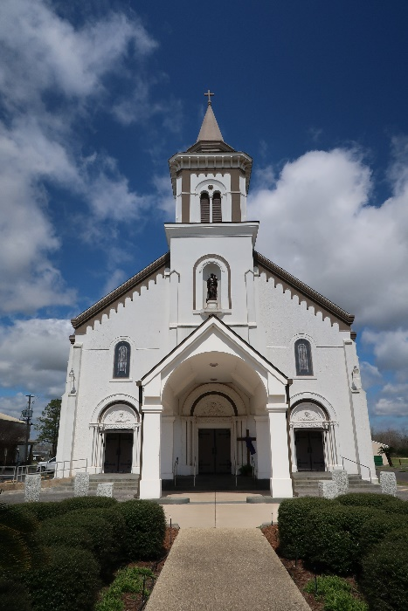

Isaac Michael Johnson lost his battle with lung cancer on Saturday, April 30, 2016, age 73.
He is survived by his devoted wife of 48 years Joan Ann H. Johnson, their daughters Talawanga Johnson-Burl (Ali) and Lakeisha Johnson-Manuel (Lajean), granddaughters Asia Johnson and Aubrey Burl; his brothers Raymond (Gwendolyn), Edward (Shirley), James, Larry (Jewel), and Charles (Alma) Johnson and Arthur (Ruth) Brooks; Sisters Glorydine Harris, Glenda Mae Diggs (Wilbert), Betty Jones and Yvonne Joseph. Also survived a host of nieces and nephews, other relatives and friends.
Employees of IMC Agrico, the Town of Lutcher, relatives and friends of the family are invited to attend the funeral services at St. Joseph Catholic Church, 2130 Rectory St. Paulina LA 70763, on Saturday May 7, 2017 at 11:00. Visitation 9:00am until service time. Internment at church cemetery. Service entrusted to Hobson Brown Funeral Home, Garyville, LA 70051, 985-535-2516.

The Advocate, Baton Rouge, Louisiana
May 4 to May 7, 2016

