Joan Ann (Hays) Johnson
Abt. 1945 – December 4, 2017

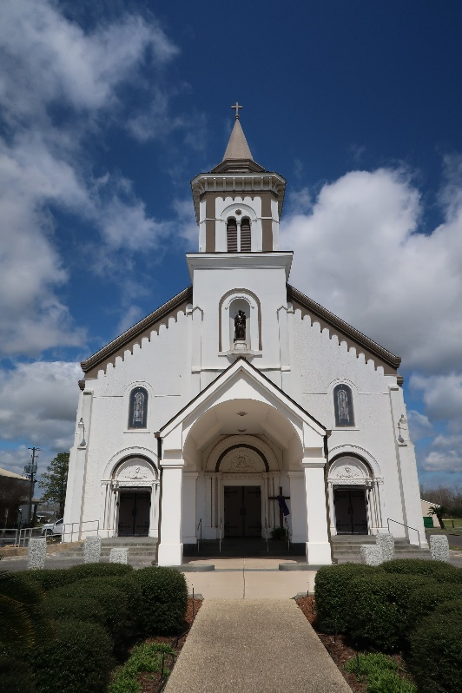

Joan Ann Hayes Johnson, a retired educator of St. James Parish School Systems, lost her battle with Multiple Myeloma on Monday December 4th 2017 at Our Lady of The Lake Regional Medical Center in Baton Rouge La at the age of 72.
Daughter of the late Henry Hayes Sr. and Jane Cola Hayes, Wife of the late Isaac Michael Johnson, Mother of Talawanga (Ali) Burl and Lakeisha (Lejean) Manuel, Grandmother of Asia Johnson and Aubrey Burl, Joan is survived by her Sisters Elaine Kirklin and Alice Folse, brother in laws Raymond Johnson (Gwendolyn) Edward Gene Johnson (Shirley), James Johnson, Larry Johnson (Jewel) Charles Johnson (Alma) and Arthur (Ruth) Brooks, sisters in laws Glorydine Harris, Glenda Mae Diggs (Wilbert), Betty Jones and Yvonne Joseph, two devoted friends Rosa Lee Gaudin and Faith Weber, Goddaughter Sharonda Harris Bailey (Jimmy) and a host of nieces, nephews other relatives and friends.
Joan is preceded by her siblings Gladys Hayes Edwards, Patricia Hayes Taylor, Henry Jr, Calvin, Charlie, and Marie Hayes, father and mother in law Arthur Johnson Sr and Rebecca Joseph Johnson, sister in law Kathleen Johnson, Carrie Mae Johnson brother in law Linton Joseph, Arthur Johnson and Percy Kirklin, niece DeAnn Johnson and nephew Irvin Hayes.
Employees of St. James Parish School system: relatives and friends of the family are invited to attend the funeral services at St. Joseph Catholic Church, 2130 Rectory St., Paulina La 70763 on Tuesday December 12, 2017 at 11 am. Visitation from 9 am until service time. Interment in church mausoleum. Services Entrusted to Hobson Brown Funeral Home, Garyville, La 70051.

The Advocate, Baton Rouge, Louisiana
Dec. 10 to Dec. 12, 2017

