Thomas Johnson, Jr.
November 17, 1933 – August 2, 2024

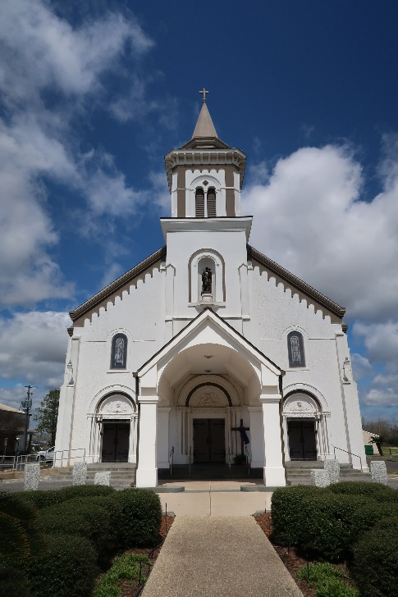

Thomas Johnson, known affectionately as Hitchcock, passed away on August 2, 2024, in Paulina, Louisiana, at the age of 90. Born on November 17, 1933, in Maringouin, Louisiana, he led a full life characterized by his dedication to his family, his church, and his community. He spent most of his adult life in New Orleans. Moved to Paulina after Hurricane Katrina in 2005.
Thomas retired from a commendable career where he worked as a Crane Hooker, Pipefitter, and Welder at Avondale Shipyards and later as a Roofer with a private company. His work ethic and skills were a testament to his dedication and hard work. A man of faith, Thomas was a devoted member and Deacon of the Star of Bethel Missionary Baptist Church at 2217 Harmony St. in New Orleans under the leadership of the late Pastor James Trench, Jr and most recently Pastor Leslie Sims. He was deeply involved in his church activities, especially in feeding the hungry every first Tuesday of the month. His generosity extended beyond his church activities; he frequently donated to the "House of Prayer" in Maringouin, Louisiana to support feeding programs led by his nephew, Minister Larry Johnson Sr.
Thomas cherished his family deeply. He is survived by his loving wife, Edith Edwards Johnson; daughters, Shelia Johnson Vigne (Glenn), Dr. Karen L. Johnson; son, Deacon Kenneth Johnson Sr. (Charmaine), and his grandchildren KJ, Martin, Michelle, Brandon, Jordan, Danielle, Dwayne, and Tracy. He also leaves behind a host of nieces, nephews, cousins, and church members.
Thomas was preceded in death by his parents, Thomas Johnson Sr. and Rosa Johnson; siblings Earl, Edward, Willie, Richard Sr., Robert, Virginia (Dorsey), Essie Mae, Rosalie (Landix), and his son, Floyd Johnson.
His hobbies included playing card games like poker and bid whist, shooting pool, and watching classic television shows and westerns such as "In the Heat of the Night," "Walker, Texas Ranger," and "Gunsmoke."
A community gathering (public visitation) of family and friends will be held on Friday, August 09, 2024 at Treasures of Life Funeral Services, 315 E. Airline Hwy, Gramercy, La. 70052 from 4-6pm. Homegoing Services will be held on Saturday, August 10, 2024 at Highway Baptist Church, 1185 Magnolia Heights St., Vacherie, La 70090 in which affiliate churches including but not limited to the surrounding communities of Maringouin, Vacherie, New Orleans- Israelite Baptist Church; Franklin Avenue Baptist Church; Christian Faith Ministries; Georgia- Victory For The World (Decatur) and Kirkwood UCC (Atlanta) are invited to celebrate his life and legacy homegoing at the above named church. Visitation begins for 9am followed by 11am service, Dr. Charles Oatis, Sr. officiating. He will be laid to rest at St. Joseph Catholic Church Cemetery Garden Mausoleum, 2130 Rectory St, Paulina, La.
Thomas Johnson will be remembered as a pillar of strength in his community, a loving family man, and a devout churchgoer whose legacy will live on through the many lives he touched.

Treasures of Life Funeral Services, Gramercy, Louisiana
August 11, 2024

