Paul Karl Keller

December 21, 1937 – April 3, 2020

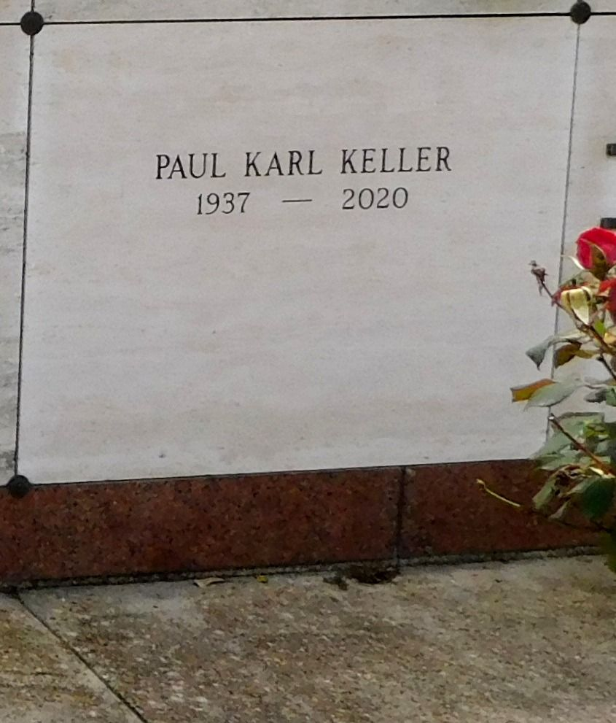

Photo by Mary Agnes Hammett

Paul Karl Keller, born December 19, 1937 in Convent, Louisiana peacefully passed away at Clarity Hospice in Baton Rouge, Louisiana on April 3, 2020 at 82 years old.

He was a lifelong resident of St. James Parish. He was a man of Catholic faith, devoting countless hours to the preservation efforts of St. Michael's Catholic Church. He dedicated his life to public service for both the citizens of St. James Parish and the state of Louisiana. Along with the many things he did for St. James Parish, during the current country's medical crisis it should be noted that he was responsible for bringing telemedicine to all of rural Louisiana when he was director of the Louisiana Department of Rural Development.

He is preceded in death by his father, Kerney Keller and his mother, Winnie Tamplain Keller. He is survived by his loving wife of 60 years, Marie Puccio Keller, his three children, Oren Paul Keller, Angela Keller Macias, and Mary Grace Keller, as well as four grandchildren, Matthew Paul Keller Macias, Katelyn Marie Keller, Mary Elizabeth Macias, and Oren Paul Keller, II. He is also survived by his honorary son and close personal friend, Carey Watis.

Because of the current gatherings restriction, there will be no funeral or memorial service.

Rose Lynn Funeral Services, Lutcher, Louisiana

April 4, 2020