1st Lieutenant Etienne Joseph Labat Jr.

September 6, 1918 – July 24, 1944

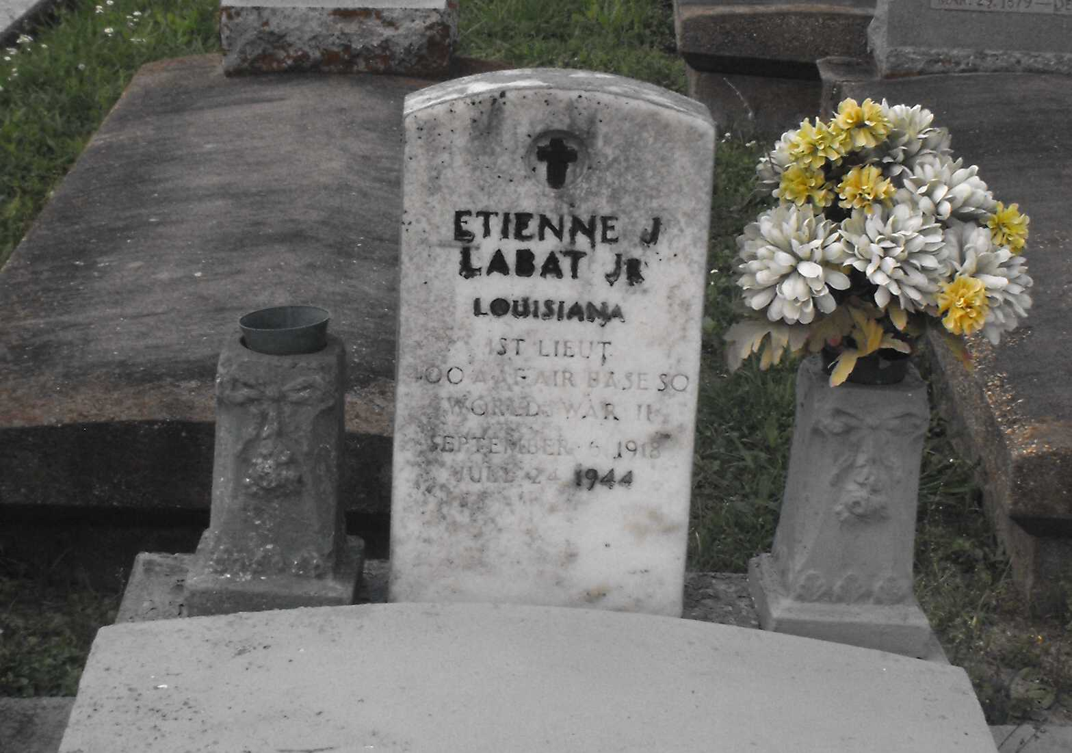

Photo by Mary Agnes Hammett

U.S. World War II Army Enlistment Records, 1938-1946

Name: Etienne J Labat  
Birth Year: 1918  
Race: White, citizen (White)  
Enlistment Date: 22 Oct 1940  
Enlistment State: Alabama; Enlistment City: Montgomery  
Branch: Quartermaster Corps  
Grade: Private  
Term of Enlistment: Enlistment for assignment to another corps area  
Component: Regular Army (including Officers, Nurses, Warrant Officers, and Enlisted Men)  
Source: Civil Life  
Education: 3 years of high school  
Civil Occupation: Sales clerks  
Marital Status: Single, without dependents  
Height: 66  
Weight: 152

U.S. Rosters of World War II Dead, 1939-1945

Name: Etienne J Labat Jr  
Gender: Male  
Race: White  
Religion: Catholic  
Cemetery Name: Louisiana  
Disposition: According to next of kin  
Service Branch: Army  
Rank: First Lieutenant  
Service number: 578251