Adele Marie Loupe

October 16, 1896 – March 15, 1980

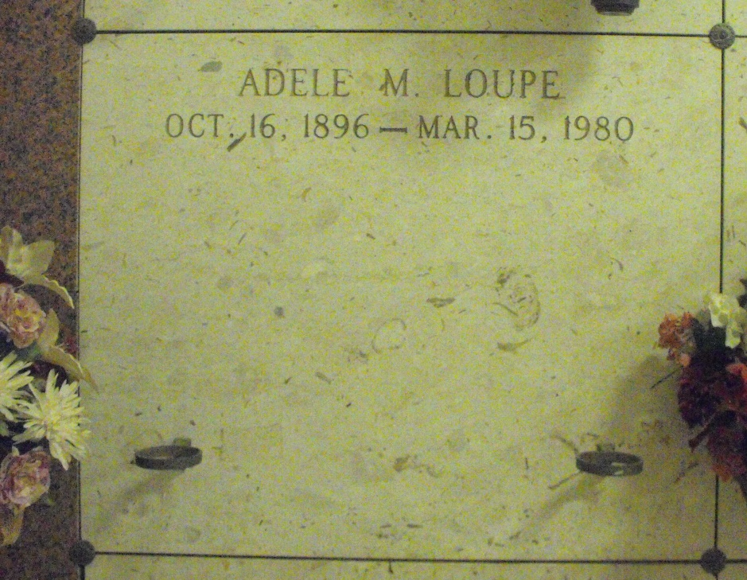

Photo by Mary Agnes Hammett

LOUPE, ADELE MARIE

Died at 12:50 p.m. Saturday, March 15, 1980, at St. James Hospital, Lutcher. She was 83, a native of Edgard and a resident of Gramercy. Visiting at Alexander Funeral Home, Lutcher, from 4 to 10 p.m. Sunday. Religious services at 10 a.m. Monday at Sacred Heart Catholic Church, Gramercy. Entombment in St. Joseph mausoleum, Paulina. Survived by two sons, Montgomery “Mack” McClung and Lewis McClung Sr.; a sister, Aloysia L. Barrios, Algiers; 10 grandchildren and three great-grandchildren. Preceded in death by a sister, Georgine DeRoche; four brothers, Edgar, Louis, Amelius and George Loupe Jr., and her parents, Marie Millet and George Loupe Sr.

Sunday Advocate, Baton Rouge, Louisiana

Sunday, March 16, 1980, p. 4C