Edgar J. Loupe

1902 – December 1, 1976

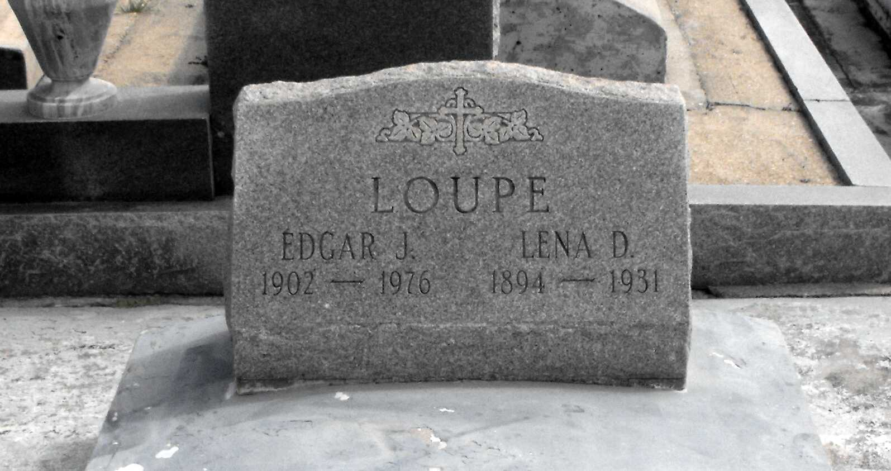

Photo by Mary Agnes Hammett

LOUPE, EDGAR J.

Died 6:45 a.m. Wednesday, Dec. 1, 1976, in Gramercy. He was 74, a resident of Gramercy and a native of Edgard. Body at Alexandria Funeral Home, Lutcher, from 5 to 11 p.m. Thursday and from 8 – 9:45 a.m. Friday. Religious services at Sacred Heart Catholic Church, Gramercy, at 10 a.m. Friday. Burial in St. Joseph Cemetery, Paulina. Survived by three daughters, Miss Agnes Loupe, LaPlace, Mrs. Amy Laiche, California, and Mrs. Velda Kebodeaux, Mermentau; one son, Albert Loupe, LaPlace; two sisters, Adele Loupe and Mrs. Aloysia Barrios; one brother, Louis Louque; 17 grandchildren; 17 great-grandchildren. Preceded in death by his wife, Mrs. Lena Decareaux Loupe; one sister, Mrs. Georgine Deroche; two brothers, Amelius Loupe and George Loupe Jr.

Morning Advocate, Baton Rouge, Louisiana

Thursday, December 2, 1976, p. 10 A