George J. Loupe Jr.

August 13, 1904 – July 3, 1966

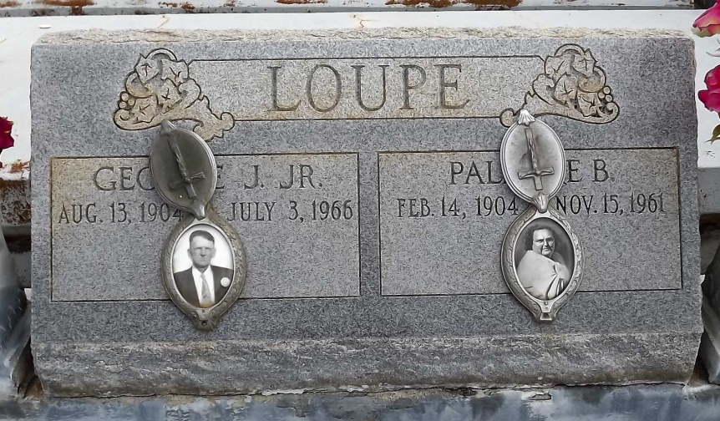

Photo by Mary Agnes Hammett

LOUPE, GEORGE J. JR.

Died Sunday at 3:30 a.m. in New Orleans at 61. A resident of Gramercy and a native of Paulina, he was an employe of Colonial Sugar Co., Gramercy. Body at Alexander Funeral Home, Gramercy, from 3 p.m. Monday until 9;45 a.m. Tuesday. Religious services will be at Sacred Heart Catholic Church, Gramercy at 10 a.m. Tuesday, conducted by Rev. Leonard Kellerman, S. M. Interment in St. Joseph Cemetery, Paulina. He was the husband of the late Palmyre Badaux and the son of the late George J. Loupe Sr. and the late Marie Millet. Survivors include a a son, Alvin P. Loupe Sr., serving with U.S. Navy in San Juan, Puerto Rico; a daughter, Mrs. Nolan DeRoche, Gramercy; three sisters, Mrs. A. Barrios, Algiers, Mrs. Georgine DeRoche and Adele Loupe, both of Gramercy; two brothers, Louis Loupe, Algiers and Edgar Loupe, Gramercy. In addition to relatives and friends, the family has invited employes of Colonial Sugar and members of Local No. 1167, United Packing House Workers of America, to the funeral.

Morning Advocate, Baton Rouge, Louisiana

Monday, July 4, 1966, p. 6A

\*\*\*\*\*

Loupe, George J. Jr died Sunday at 3:30 a.m. in New Orleans at age 61. A resident of Gramercy and a native of Paulina, he was an employee of Colonial Sugar Co., Gramercy. Body at Alexander Funeral Home, Gramercy, from 3 pm Monday until 9:45 am Tuesday. Religious services will be at Sacred Heart Catholic Church, Gramercy, at 10 a.m. Tuesday, conducted by Rev. Leonard Kellerman, S. M. Interment in St. Joseph Cemetery, Paulina. He was the husband of the late Palmyre Badaux and the son of the late George J. Loupe Sr. and the late Marie Millet.  
 Survivors include a son, Alvin P. Loupe, Sr., serving with U.S. Navy in San Juan, Puerto Rico; a daughter, Mrs. Nolan (Olive) Deroche, Gramercy; three sisters, Mrs. A. Barrios, Algiers, Mrs. Georgine DeRoche and Adele Loupe, both of Gramercy; two brothers, Louis Loupe, Algiers and Edgar Loupe, Gramercy.  
 In addition to relatives and friends, the family has invited employes of Colonial Sugar and members of Local No. 1167, United Packing House Workers of America, to the funeral.

Times-Picayune, New Orleans, Louisiana

Tuesday Morning, July 5, 1966, Section 1, p. 10