Alvin F. Louque Sr.

October 4, 1910 – July 18, 2003

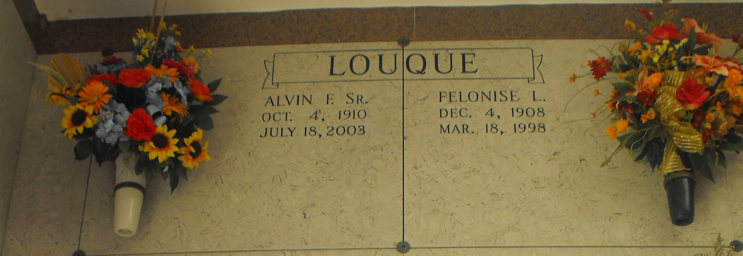

Photo by Mary Agnes Hammett

Alvin F. Louque, Sr. Died On Friday, July 18, 2003. He Was 92 Years Old And Resided In Gramercy, La. For 60 Years.  
 His Survivors Include 3 Daughters, Along With Their Husbands, Joyce And Ronald Landry Of Reserve, La., Judith And Jerry Dubose Of Baton Rouge, La. And Iris And Wallace Poche Of Paulina, La. His Surviving 5 Sons And Their Wives Include, Eddie Louque Of Waco, Tx., Harry And Wife Betty Of St. Amant, La., Alvin, Jr. And Wife Beverly Of Laplace, La., Gary And Wife Linda Of St. Amant, La., And Lynn And Wife Donna Of Laplace, La. His Surviving Sisters Are Stella Thornton Of Metairie, La., And Merle Day Of Baton Rouge, La. He Is Also Survived By Numerous Grandchildren, Great- Grandchildren, And Great-Great-Grandchildren.  
 Mr. Louque Was Preceded In Death By His Wife, The Late Felonise Lambert Louque. They Were Married For 68 Years. A Son, The Late Francis Louque, And A Daughter The Late Elaine Breaud. His Parents, The Late Oscar And Louisa Martin Louque And 2 Brothers, The Late Garland And Herbert Louque And 1 Sister The Late Violet Stansbury.  
 Mr. Louque Will Always Be Remembered As The 'House Painter' As He Painted Many Of The Older Homes In The Area, Including St. Joseph Rectory In Paulina, La.  
 The Mass Of Christian Burial Will Be Held At 11 Am At Sacred Heart Church, Gramercy, La. On Monday, July 21, 2003 With Fr. Ed Fuss Officiating. Friends And Relatives May Call Beginning At 8:30am Until Funeral Time At The Church. Burial To Follow At St. Joseph Mausoleum, Paulina, La. Alexander Funeral Home, Lutcher, La. In Charge Of Arrangements.  
  
Published in The Times Picayune, New Orleans, Louisiana

July 20, 2003