Harris George Louque, Jr.
April 17, 1945 - September 17, 2024

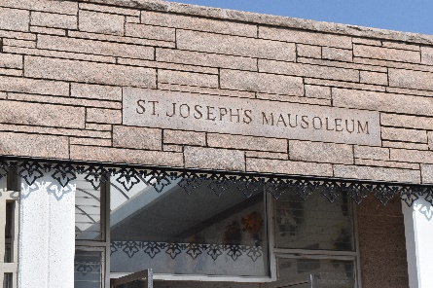

Harris George Louque, Jr. passed away on Tuesday, September 17, 2024 at the age of 79. He was born in Lutcher, LA and a resident of Gramercy, LA.
Beloved husband of 59 years to his wife Gaynell Troxler Louque. Loving father of Theron Louque (Danielle) and Tanya Bourgeois (Chad). Pawpaw of Chelsea Louque (Jesse), Trevor Louque (Jeanne), Luke Bourgeois (Natalie), and Nicol Bourgeois-Andry (Brandon). Pappy of Collins and Cameron Bourgeois.
Harris is also survived by his siblings, Dianne Duhe (the late Gerald), Rose Michel (the late Mike), Robert Louque (Bertha), and sister-in-law Gwen Louque. Also survived by numerous nieces, nephews, cousins, and friends.
He is preceded in death by his parents, Noella Oubre Louque and Harris George Louque Sr., and brother Mike Louque.
Harris proudly served in the United States Army during Vietnam. He loved to hunt deer, fish, go camping with family and friends, and watching various sports. Harris was a proud active member of the VFW.
Relatives and friends are invited to attend the Visitation and Funeral Mass at Most Sacred Heart of Jesus Church, 616 E. Main St., Gramercy on Saturday, September 21, 2024. Visitation at the church from 8:30 a.m. to 12:00 p.m. followed by a Funeral Mass at 12:00 p.m. Interment in St. Joseph Cemetery, Paulina, LA.
In lieu of flowers, please send donations to Sacred Heart Catholic Church Building Fund, P.O. Box 129 Paulina, LA 70763.

Rose Lynn Funeral Home, Lutcher, Louisiana
September 19, 2024

