Bertha (Rome) Lousteau

September 1, 1917 – February 27, 2001

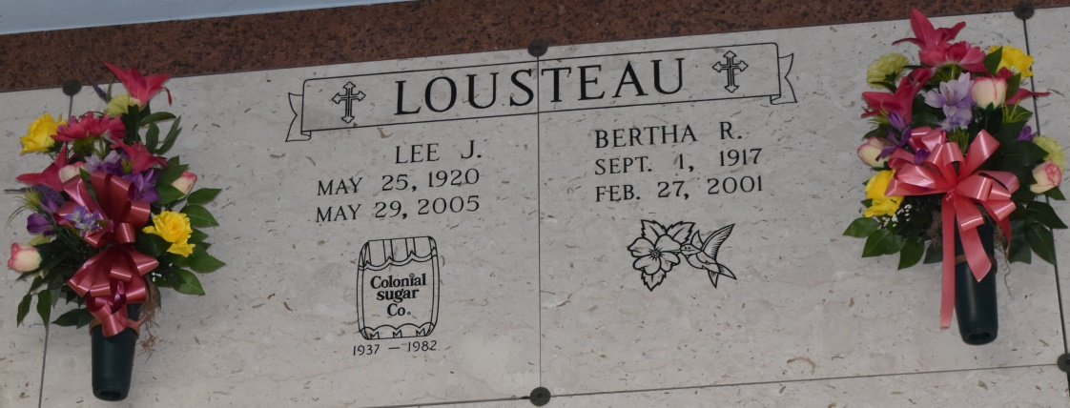

Bertha Rome Lousteau, 83

A homemaker who resided in Lutcher and Gramercy during her married life and grew up in Romeville, she died at 11:08 a.m. Tuesday, Feb. 27, 2001, at St. James Parish Hospital. She was 83 and was born in Wallace.

Visiting at Sacred Heart Catholic Church, Gramercy, from 9 a.m. Thursday until Mass of Christian Burial at 11 a.m., concelebrated by the Rev. Paul Cabatta and the Rev. Louis Poché. Entombment in St. Joseph Mausoleum.

Survived by her husband of 58 years, Lee J. Lousteau, Lutcher; a daughter and son-in-law, Irene and Raymond Poché Sr., Gramercy; a sister, Doris St. Pierre, Metairie; two grandchildren, Raymond Poché Jr. and his wife, Ginger, and Shannon Irene Poché; and three great-grandchildren, Philip, Sydney and Ruston Poché. Preceded in death by her parents, Roger and Irene Gaudet Rome; two brothers, Earl and Roger Rome Jr.; and a sister, Mae Jeanne Stewart. She was a member of St. Anne Society and St. James Community Theatre.

Alexander Funeral Home, Lutcher, in charge of arrangements.

Advocate, The (Baton Rouge, LA)

Wednesday, February 28, 2001