Eula (Vedros) Lucia

December 21, 1914 – April 12, 2008

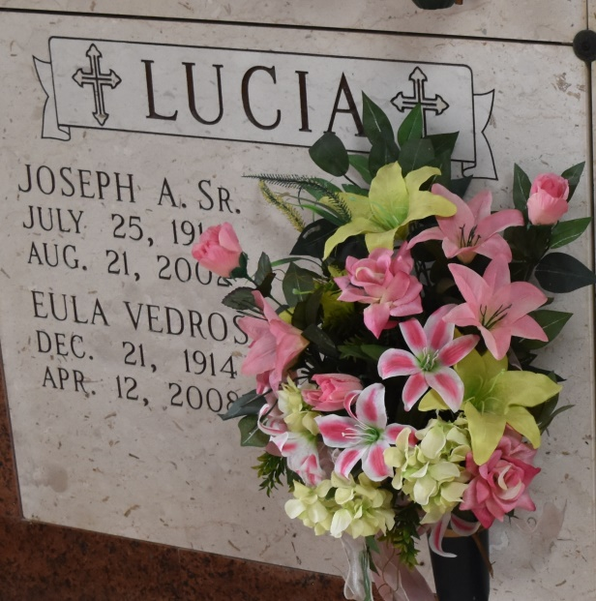

Eula Vedros Lucia, a resident of LaPlace and native of Lutcher, died Saturday, April 12, 2008, at Twin Oaks Nursing Home. She was 93, a homemaker and a retired proofreader for The L'Observateur.

Visiting at Rose Lynn Funeral Home, 1870 Cabanose Avenue, Lutcher, on Tuesday from 10 a.m. until services at noon at the funeral home. Burial at St. Joseph's Mausoleum, Paulina.

She is survived by her children Joseph Lucia, Jr, Patricia L. Austin and husband Michael, Ellis Lucia and wife Bevil Knapp; brother Jamsel Vedros; and special friend, Earline Bergeron. She was lovingly called "Mammy" by her eight grandchildren and eight great-grandchildren. She was preceded in death by her husband of 60 years, Joseph Lucia, Sr.; parents, Ellis and Laura Vedros; brother, Percy Vedros; sisters, Ione Bourgeois, Doris Bernard, Anna Lee Martin; and great-grandson Zachary Hoover.

In lieu of flowers, donations can be made to St. John Parish Animal Shelter, 124 Water Plant Rd., LaPlace, LA 70068.

Published by The Times-Picayune (New Orleans, LA) from Apr. 14 to Apr. 15, 2008.