Darnell "Lu" Joseph Luquette

August 2, 1941 - October 3, 2024

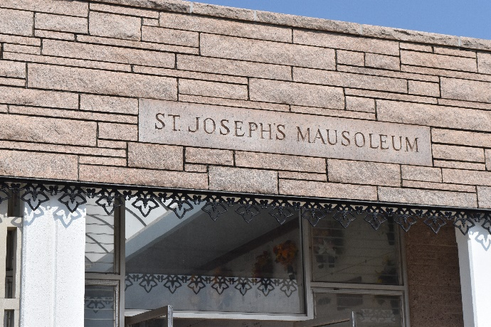

Darnell “Lu” Joseph Luquette passed away on Thursday, October 3, 2024 at the age of 83.  He was born in New Orleans and a resident of Gramercy, LA.

Beloved husband of the Joyce Roussel Luquette. Loving father of Leslie Dicharry (Marc) and Lance Luquette.  Grandfather of Jacie Prejeant (Raleigh), Julie Theriot (Taylor), and Codi Dicharry.  Great grandfather of Noah Prejeant, Bryn Prejeant, and Quinn Theriot. Son of the late Arthur Luquette and Ruby Lambert Luquette.  Brother of Darryl Luquette.

Lu proudly served in the US Navy. When he returned home, he worked at Colonial Sugar Refinery, until his retirement 43 years later.

Relatives and friends are invited to attend the Visitation and Funeral Mass at St. Joseph Catholic Church, 2130 Rectory St., Paulina on Wednesday, October 9, 2024.  Visitation will be held at the church from 9:00 a.m. to 11:00 a.m. followed by a Funeral Mass at 11:00 a.m.  Interment in St. Joseph Cemetery, Paulina, LA.

Rose Lynn Funeral Home, Lutcher, Louisiana

October 5, 2024