Noelie Marie (Rome) Martin
February 14, 1925 - October 17, 2023

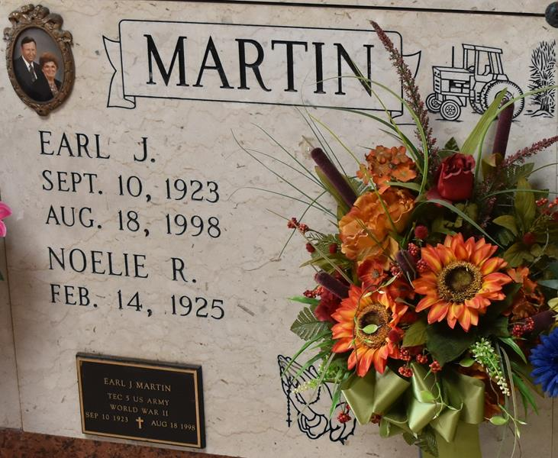

Noelie “Nell” Marie Rome Martin departed this life on Tuesday, October 17, 2023, at the age of 98. A native of Vacherie, LA and a resident of Paulina, LA, she was born to Froizin and Noemie Becnel Rome on February 14, 1925.
She leaves to cherish her memory her 2 children – Gary Martin and Jackie Schexnayder (Lowell); 4 grandchildren – Gary Martin, Jr. (Terri), Brad Martin (Nikki), Christie Prince, and Julie Schexnayder; 7 great-grandchildren – Thomas Martin, Lance Martin, Avery Martin, Jake Martin, Abigail Prince, Olivia Prince, and Alex Prince; 3 siblings – Richard Rome, Joyce Poche and Gertrude “Gert” Guidry; 2 brothers-in-law – Michel Martin, Jr. and Francis Simon; two sisters-in-law – Annette Rome and Beryl Rome; and numerous nieces, nephews, cousins and friends. Nell was preceded in death by her parents; her husband – Earl Martin; 8 siblings – Frank Rome, Fernand Rome, Anthony Rome, Jean Paul Rome, Stella Martin, Margaret Rome, Beverly St. Pierre, and Janice Nobile; and one daughter-in-law – Rodie Martin.
In addition to being a beloved daughter, wife, mother, mother-in-law, grandmother, great-grandmother, sister, sister-in-law, aunt, neighbor, cousin and friend, Nell was also a faithful member of the Catholic Daughters and St. Anne Altar Society of St. Joseph Catholic Church. She was a renowned cook who loved traveling and visiting with friends and family.
Friends and relatives are invited to her visitation on Tuesday, October 24, 2023 from 9:00 a.m. to 11:00 a.m. at St. Joseph Catholic Church in Paulina, LA, followed by a Mass of Christian Burial. The Burial will follow at the church mausoleum.
Nell’s family would like to offer heartfelt gratitude to the staff at St. James Hospital for their compassionate care.

Rose Lynn Funeral Services, Lutcher, Louisiana
October 21, 2023

