Rory Patrick Matherne

October 4, 1966 – February 9, 2005

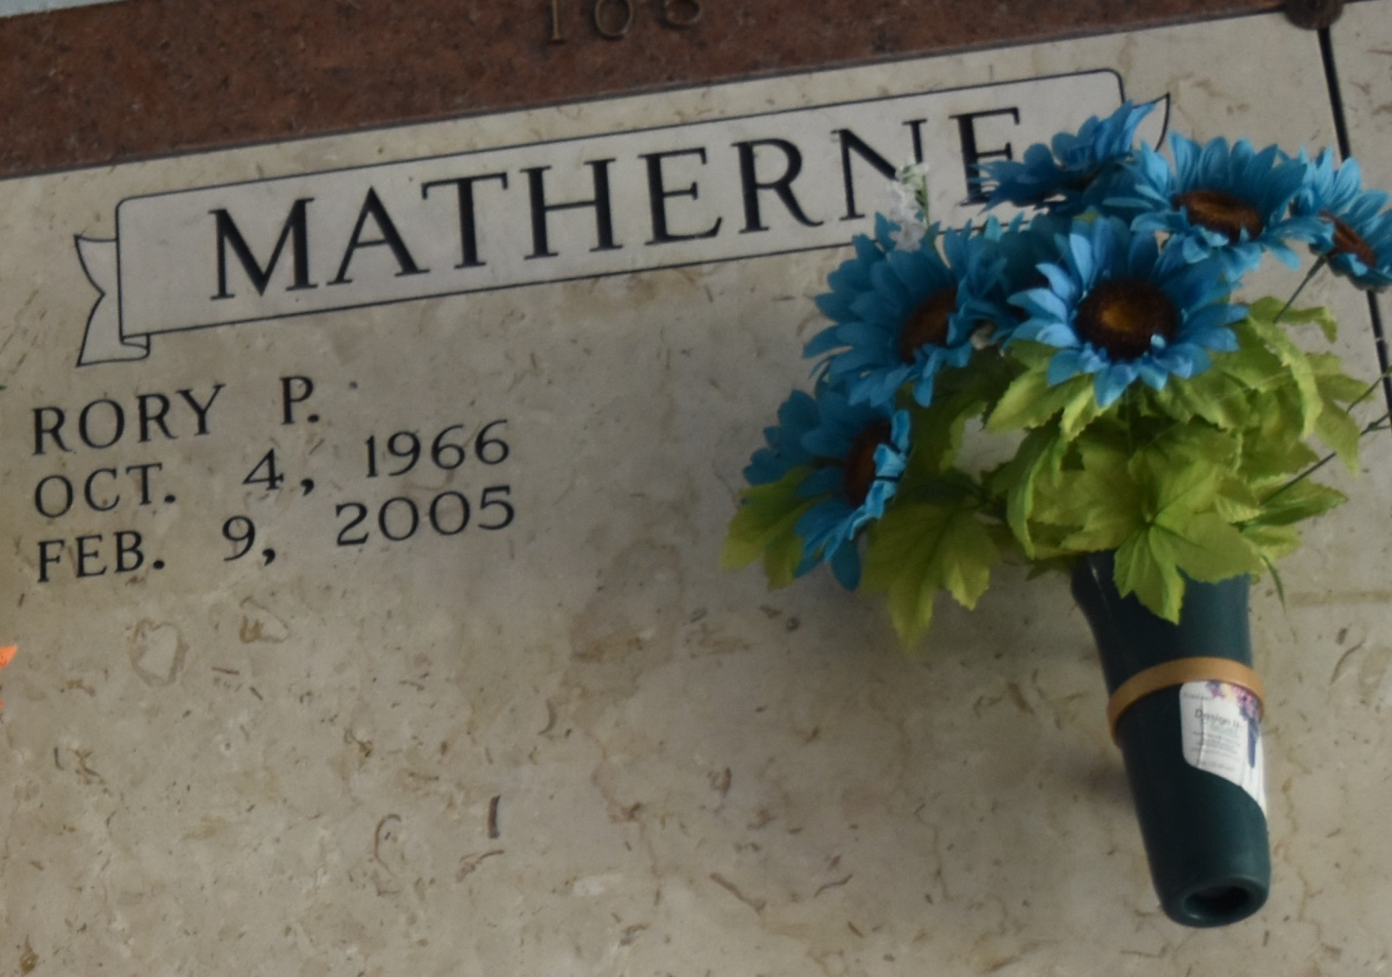

Rory Patrick Matherne, age 38, born on October 4, 1966 and died on Wednesday, February 9, 2005 at 4:09 pm. A native and resident of Lutcher, LA.

Survived by his wife: Twyla Moore Matherne; two daughters: Lindsey and Kaitlyn Matherne; mother and step-father: Elinor Abreo and Steve Darnell; father and step-mother: Ronald and Ethel Matherne; two brothers: Ronald ""Ron'' Jr., and Eric Matherne; two sisters: Barbree M. Duhe' and Celeste M. Duhe'; and step-brothers: Craig and Chris Himel.

Visitation will be on Saturday, February 12, 2005 from 6 PM until 10 PM at Rose Lynn Funeral Sevices in Lutcher, LA. and on Monday, February 14, 2005 from 8 AM until funeral time. A Mass of Christian Burial at 10:00 AM at Sacred Heart Catholic Church in Gramercy, LA.

Published by The Times-Picayune (New Orleans, LA) on Feb. 11, 2005.