Donald Paul McLean

July 1, 1963 – October 11, 2009

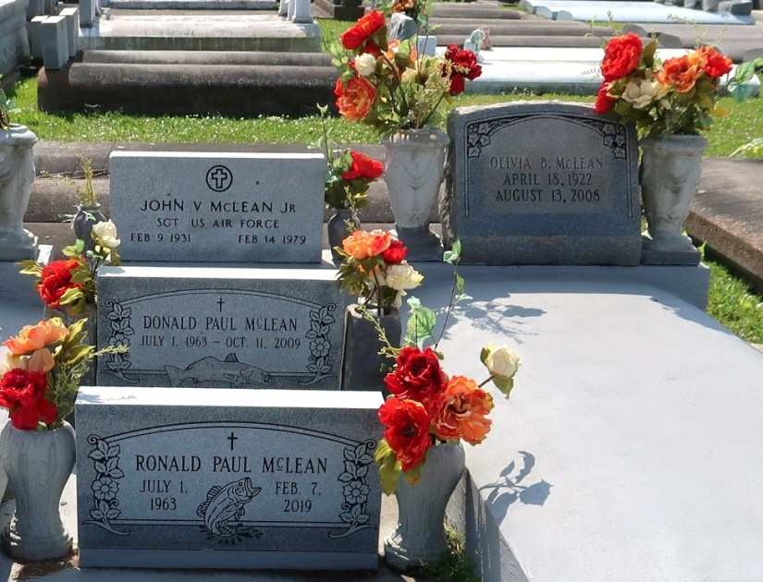

Donald (Shrune) Paul McLean Sunrise - July 1st, 1963 Sunset - October 11th, 2009 Survived by his son, Donald (D.J.) Paul McLean Jr. Also survived by his former wife Candice Guidry; his companion Patricia (Mimi) Ferry; five brothers and four sisters, Kathleen and Ernie, Rodney and Pat, Poochie and Eddie, Tiger and Lucille, Pat and Joe, Wayne and Sheila, John and Kim, Doris and Danny, Ronald and Debbie; and many dear nieces, nephews, an Uncle, and many close friends and neighbors. Preceded in death by his mother and father, Olivia Babin LeBlanc McLean and John V. McLean Jr. Donald was previously employed by Wal Mart and St. John Trucking. He very much enjoyed spending time with his son DJ, and also enjoyed fishing and hunting, gardening and visiting with family and friends. Donald will be sadly missed and very fondly remembered by all who knew him. A lifelong resident of LaPlace, LA. Visitation on Thurs, October 15, 2009, at 12 noon at Alexander Funeral Home, Lutcher, LA. A Graveside Service will follow at 3PM at St. Joseph's Cemetery, Lutcher, LA.

Published by The Times-Picayune (New Orleans, LA) on Oct. 14, 2009.