Ronald Paul McLean

July 1, 1963 – February 7, 2019

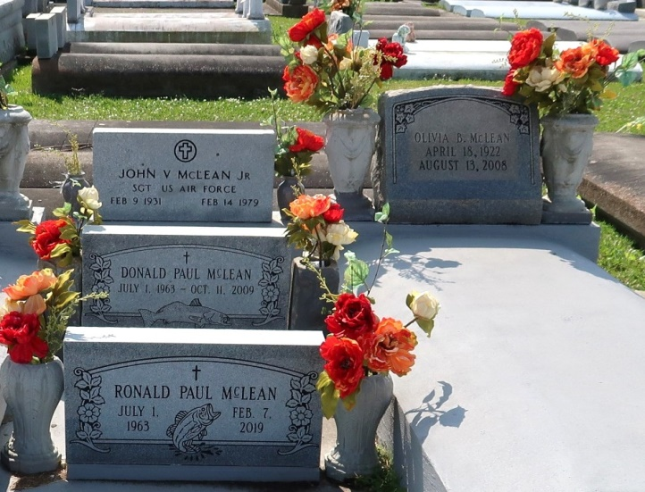

Ronald Paul McLean passed away peacefully on Thursday, Feb. 7, 2019, at the age of 55. He is the son of the late John McLean Jr. and Olivia LeBlanc McLean.

He was preceded in death by his brothers, Donald McLean (Candace) and Usley LeBlanc (Lucille) and sister Patricia LeBlanc Frye (Joe).

Ronald was the father of Chad (Amber), Blake (Lacey) and Tyler and grandfather of Mason, Patrick, Chad Jr., Braxton and Ezra. He is survived by former wife Debbie Wetzel Morgan, brothers and sisters Kathleen (Ernie), Rodney (Pat), Carol (Eddie), Wayne (Sheila), John (Kim) and Doris (Danny) and a host of nieces, nephews, cousins, relatives and friends.

He was a lifelong resident of LaPlace. Ronald was a retired electrician with C.J.’s Electric and All-Star Electric, an avid fisherman and adventurous storyteller. He enjoyed gardening, woodworking, cooking and family get-togethers.

Family and friends are invited to attend a visitation and mass on Saturday, Feb. 23 at St. Joseph’s Church in Paulina. Visitation begins at 10 a.m., followed by a Mass at 11 am. Internment will be at St. Joseph’s Cemetery at a later date.

L’Observateur, LaPlace, Louisiana; Wednesday, February 13, 2019