Keith Bernard Millet

August 7, 1957 – December 2, 2012

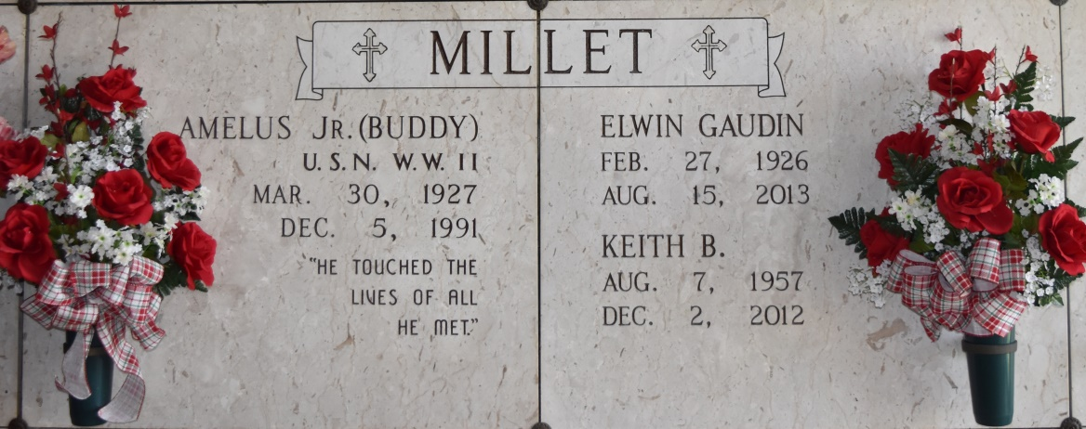

Keith Bernard Millet, 55, a loving son, brother, uncle and friend to many. He died at the home of his brother, Dean and sister-in-law, Mary on Sunday, December 2, 2012 after a courageous battle with cancer.

He was the loving son of Elwin G. Millet and the late A.J. "Buddy" Millet. Beloved brother of Dean Millet, Sr. and his wife Mary, and Uncle of Michele Duhe (Mike), Vickie Bradford (Kenny), Dean "Buddy" Millet (Celeste), Chad Millet (Heidi) and their children. He will also be sadly missed by his pet, Roxie.

Keith was loved and cherished by his family and friends. He will be fondly remembered for his love of life. He was an avid carnival enthusiast. Keith was a resident of New Orleans; a city that he LOVED. The family wishes to extend heart-felt thanks to St. Joseph Hospice, Select Properties, LTD, and all his special friends.

Visitation will be on Thursday, December 6, 2012 from 9:30 a.m. to 11:30 a.m. followed by a Memorial Service at Sacred Heart Catholic Church in Gramercy. Burial will be at a later date. ROSE LYNN FUNERAL SERVICES is in charge of the arrangements. To sign and view the family guestbook, please visit [www.roselynnfuneralhome.com.](http://www.roselynnfuneralhome.com/)

Published by The Advocate (Baton Rouge, LA) from Dec. 3 to Dec. 5, 2012.