Wayne Joseph Moran
January 28, 1948 - August 31, 2024

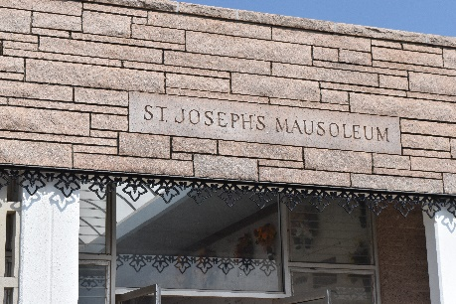

Wayne Joseph Moran passed away surrounded by his loving family on Saturday, August 31, 2024 at the age of 76 after a courageous battle with cancer. He was born in Gonzales, LA and was a resident of Lutcher, LA. Wayne was a US Army Veteran in the Vietnam War and retired from Colonial Sugars after 35 years of service. In his spare time, he enjoyed bass fishing, spending time outdoors and spending time with his family and friends.
Beloved husband of Norma Simpson Moran for 57 years. Loving father of Jeffrey Wayne Moran (Paulette), Kathy Moran Benton (Randy) and Matthew Gene Moran (Laura LeBlanc). Grandfather of Alexis Moran Laney (Drake), Mallory Katherine Benton, Cole Joseph Benton and Kane Matthew Moran. Son of the late Delores Lee Moran and Wilmon Joseph Moran. Brother of Deborah Gail Moran (the late Todd Kilburn). Brother-in-law of Danny and Lois Wheat. Uncle of Christy (Travis), Chasity (Edwin), Jennifer (Randall), Kristen and the late Zachary. Also survived by many extended family members.
Relatives and friends are invited to attend the Visitation and Funeral Mass at St. Joseph Catholic Church, 2130 Rectory St., Paulina on Friday, September 6, 2024. Visitation will be held at the church from 9:00 a.m. to 11:00 a.m. followed by a Funeral Mass at 11:00 a.m. Interment in St. Joseph Cemetery, Paulina, LA.
Rose Lynn Funeral Home, Lutcher, Louisiana
Sept. 3, 2024

