Ralph Charles Murry
July 21, 1952 – September 16, 2024

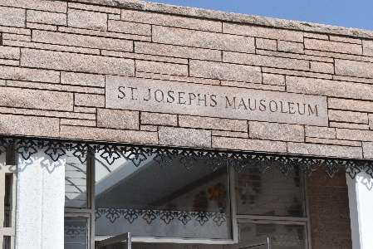

Ralph Charles Murry was born on July 21st 1952 and passed away peacefully on Monday, September 16, 2024 at the age of 72. He was a native of New Sarpy, LA and was a resident of Paulina, LA.
Beloved husband of 54 years to his wife Sharon Malbrough Murry. Loving father of Angela Loupe (Avery) and Grandfather of Savannah and Emily Loupe. Ralph is also survived by his siblings, Brenda Caillouet (Warner) and Rodney Murry. Godchildren, Leigh Reed (Craig), Ryan Malbrough (Jessica), and Tiffany Thomas. Also survived by numerous loving nieces, nephews, and relatives.
He is preceded in death by his brothers, Ernest Murry and Fabien “Joey” Murry Jr., sisters, Cecelia (Louis Sr.) and Jean Williams (Wayne Sr.), and parents, Fabien Sr. and Mary Murry.
Ralph truly enjoyed spending time with his family, wood carving, gardening, caring for his chickens, and taking road trips with his loving wife. He was deeply loved by his wife, daughter, and granddaughters and will be missed by everyone who has known him.
Relatives and friends are invited to attend the Visitation and Memorial Mass at St. Joseph Catholic Church, 2130 Rectory St., Paulina on Thursday, September 26, 2024. Visitation will be held at the church from 9:00 a.m. to 11:00 a.m. followed by a Memorial Mass at 11:00 a.m. Interment in St. Joseph Cemetery, Paulina, LA.

Rose Lynn Funeral Home, Lutcher, Louisiana
September 19, 2024

