Allen Jospeh Oubre

December 2, 1938 – April 12, 1995

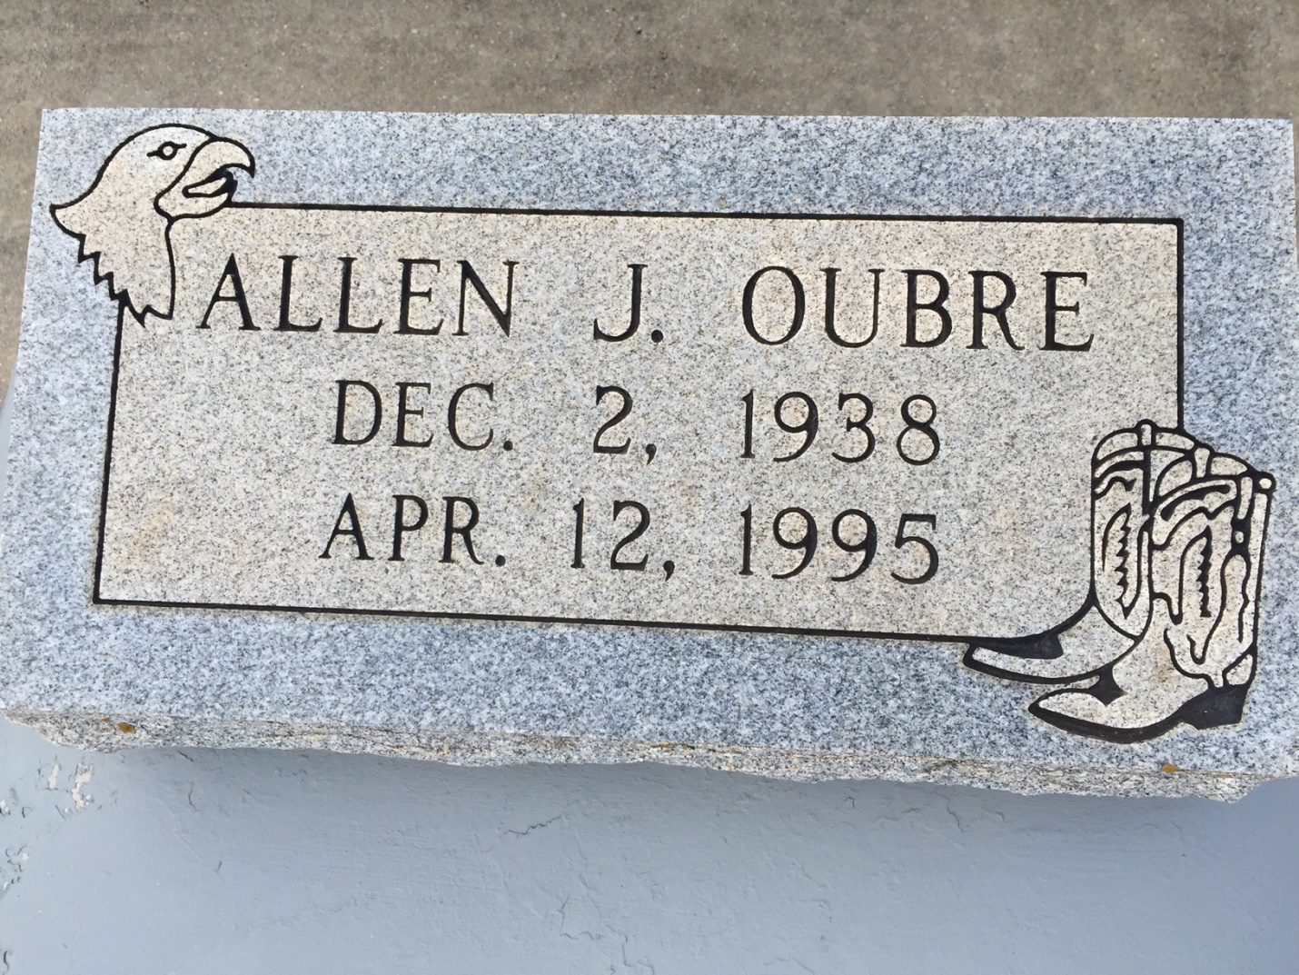

Photo by Bobby

Allen 'A.J.' Oubre, A Retired Truck Driver, Died Wednesday Of Cancer At St. James Parish Hospital In Lutcher. He Was 57. Mr. Oubre Was Born In Reserve And Lived In Gramercy For Many Years.  
  
Survivors Include His Wife, Shirley Cortez Oubre; A Son, Alvin Vicknair Jr. Of Reserve; Two Daughters, Shirley Ann Rodrigue Of Donaldsonville And Mamie Marie Stein Of Reserve; A Brother, Melvin Oubre; Three Sisters, Ruby, Ina And Julia Oubre; 12 Grandchildren; And Three Great-Grandchildren.  
  
A Funeral Will Be Held Today At 2 P.M. At Alexander Funeral Home In Lutcher. Burial Will Be In St. Joseph Cemetery In Paulina.  
  
Times Picayune, New Orleans, Louisiana

April 13, 1995