Verlin (Zimmer) Oubre

March 4, 1925 – November 11, 2016

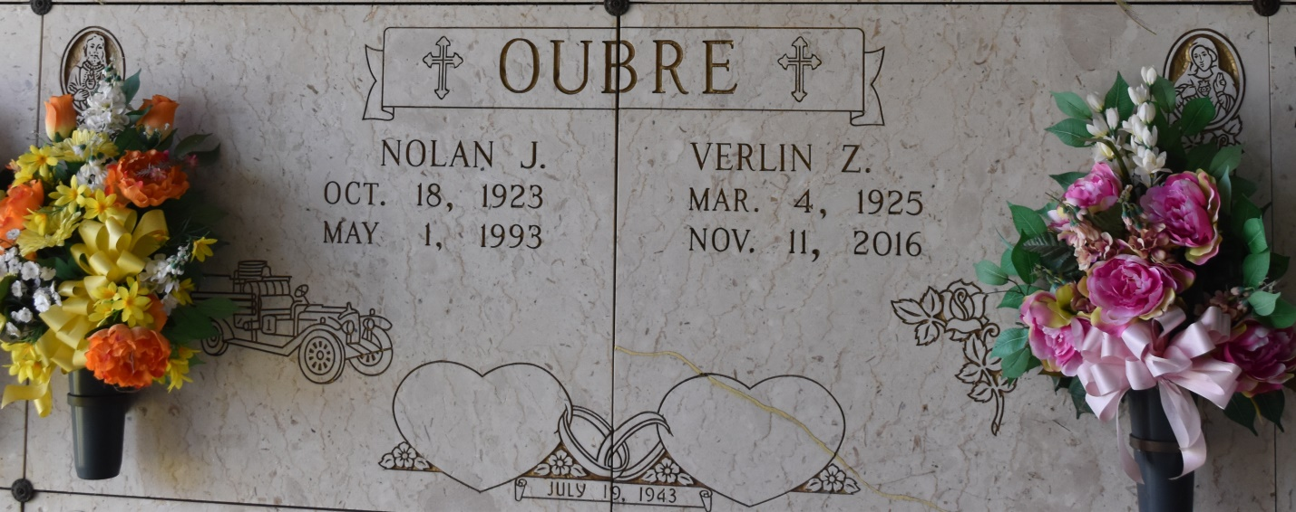

Verlin Zimmer Oubre, was born on March 4, 1925 in Lutcher, LA and lived in Gramercy, LA after her marriage. She passed away on Friday, November 11, 2016.

She is survived by her 3 children, Wayne J. Oubre, Susan O. Schexnayder, and Nolan J. Oubre, Jr. She is also survived by her 3 grandchildren: Rexann Roussel, Guy Schexnayder, and Tina O'Bryant as well as her 7 great-grandchildren and 3 great-great-grandchildren and sisters, Myrel Love, and Judy Donaldson.

She is preceded in death by her husband of 49 years, Nolan J. Oubre, Sr., her parents, Gladys Boutte Zimmer and Robert Zimmer and step-mother, Agnes Zimmer, and brother Eddie Zimmer.

She was a graduate of Lutcher High School. Visitation will be on Monday, November 14, 2016 at Sacred Heart Catholic Church in Gramercy, La from 9:00 a.m. until 11:00 a.m. followed by a Mass of Christian Burial at 11:00 a.m. Burial will be in St. Joseph's Mausoleum. Rose Lynn Funeral Services, 1870 Cabanose Ave., Lutcher, La is in charge of the arrangements. To sign and view the family guestbook, please visit [www.roselynnfuneralhome.com.](http://www.roselynnfuneralhome.com/)

Published by The Advocate from Nov. 12 to Nov. 14, 2016.