Gabriel Lester Pertuis

February 26m 1906 – May 9, 1966

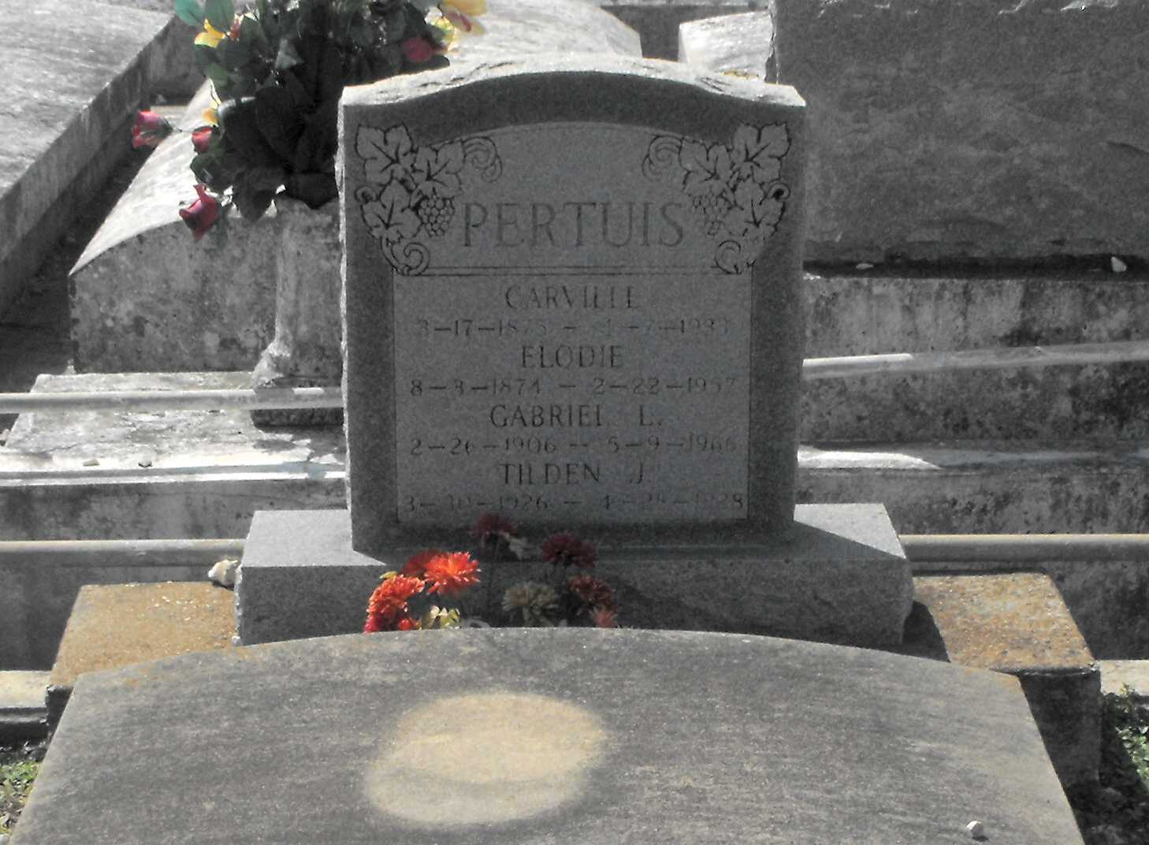

Photo by Mary Agnes Hammett

PERTUIS, LESTER G.

Died Monday, May 9, at 2:15 a.m. in Charity Hospital, New Orleans. Age 60, he was a resident of Gramercy and a native of Lutcher. Body at Alexander Funeral Home, Lutcher, from 9 a.m. Tuesday until 8:45 a.m. Wednesday. Religious services at 9 a.m. Wednesday in Sacred Heart Catholic Church, Gramercy, with interment in St. Joseph Cemetery, Paulina.

Survivors include three sisters, Mrs. Walter Millet of Port St. Joe, Fla., Mrs. Frederic Roper of Lutcher and Mrs. Alonzo Menuet of Gramercy; and one brother, Robert Pertuis Sr. of Gramercy. He was preceded in death by his parents, Carville A. and Elodie Berthelot Pertuis, and a brother, Rodney Pertuis.

The Times-Picayune, New Orleans, LA; Saturday, F