Jean Paul Rome

March 12, 1930 - April 02, 2017

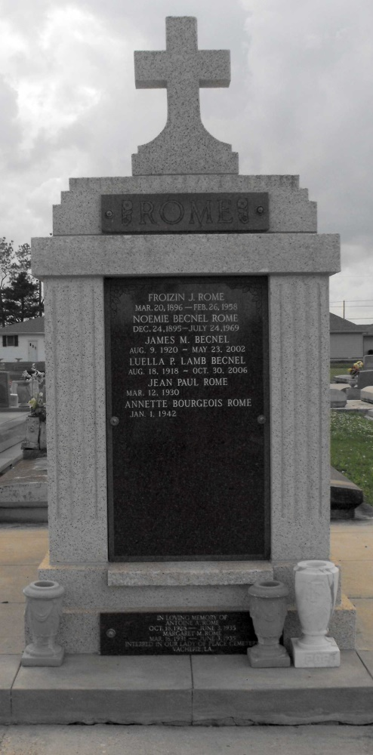 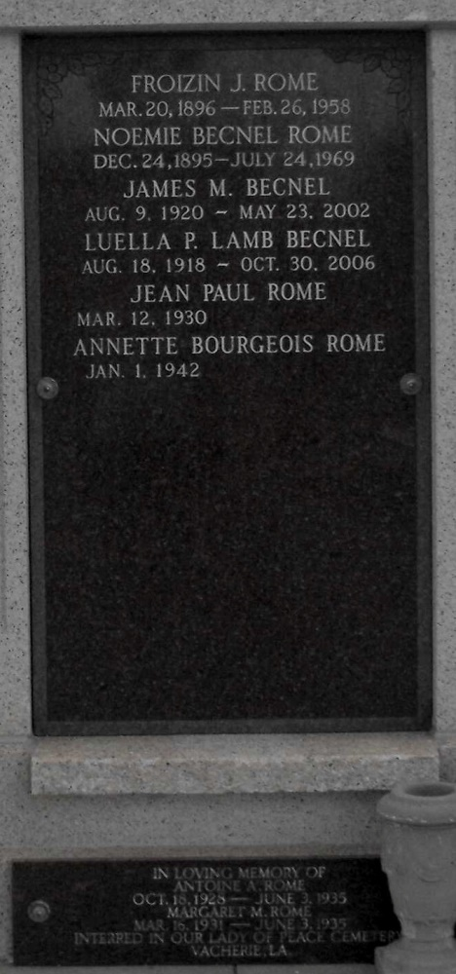

Photos by Mary Agnes Hammett

Jean Paul Rome of Lutcher, LA passed peacefully from this life to the next on April 2, 2017 at the age of 87.  Beloved husband of Annette Bourgeois Rome for 55 years and loving father to Dennis (Nicole), Rhonda Tassin (Jeff), Joy St. Pierre (John Michael), and Jeannette Roussel (Jason).  Adored Grandfather of Kaci, Holly, Kristen, Brent, Brooke, Nicholas, April, Preston, and Mason.   
  
He is survived by a brother, Richard Rome and sisters:  Noelie “Nell” Martin, Joyce Poche, Gertrude “Gert” Guidry, and Beverly St. Pierre.  He is also survived by numerous in-laws, nieces, nephews, cousins, and friends.  He was preceded in death by his parents, Froizin and Noemie Becnel Rome; brothers:  Frank, Fernand, Anthony and sisters:  Stella Martin, Janice Nobile, and Margaret Rome.   
  
Jean Paul graduated from Lutcher High School and retired from Kaiser Aluminum in Gramercy, LA after 33 years of service as an electrician.  He was a devoted parishioner of St. Joseph Catholic Church in Paulina, LA.  He served his country in the US Air Force and was a member of local VFW Post 5852.  He was also a long-time member of the St. James Boat Club.  He was an avid dancer and also enjoyed hunting, fishing, coaching youth football, cooking, and gardening.   
  
The family would like to extend thanks to the staff of the Southeast Louisiana War Veterans Home in Reserve, LA for the care provided to Jean Paul during his 15-month residency.  We would also like to thank the doctors, nurses, and staff of St. James Parish Hospital, Amedisys Hospice, and St. Elizabeth Hospital ICU for their great care and comfort.  In lieu of flowers, donations can be made to the Louisiana Alzheimer’s Association, 3445 N. Causeway Blvd., Suite 9202, Metairie, LA 70002.

A visitation in his honor will be on Tuesday, April 4, 2017 at Rose Lynn Funeral Services, 1870 Cabanose Ave., Lutcher, LA from 6:00 p.m. until 9:00 p.m.  The visitation will resume on Wednesday, April 5, 2017 from 8:00 a.m. until 10:30 a.m. at the funeral home followed by a Mass of Christian Burial at Sacred Heart Catholic Church in Gramercy, LA.  Burial will follow in St. Joseph Cemetery, Paulina, LA.  To sign and view the family guestbook, please visit [www.roselynnfuneralhome.com](http://www.roselynnfuneralhome.com)

Published online for the Rose Lynn Funeral Home, Lutcher, Louisiana