Joseph C. Rome
October 1, 1959 – September 25, 2024

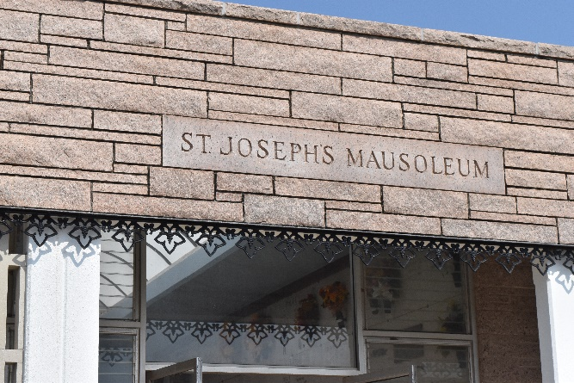

Joseph C. Rome was born on October 1, 1959 and passed away on September 25, 2024 at the age of 64. He was a native of Lutcher and a resident of Paulina, LA.
He was the son of the late Leland J. Rome and Mary K. Rome. Brother of James Rome, Marsha Waguespack (Jody), Linda Taylor (Howard) and the late Shirley Rouillier. The uncle of Trey, Bill and Kim Rouillier, Brittany and Jenna Rome, Casey and Tracy Waguespack, Jessica and Kelly Rouillier and Matthew Mosley. He was also a host of many great nieces and nephews. He was a very loving and kind person who lived life to the fullest.
A special Thank You for the Matherne family for their generosity given to him throughout the years (Kimberly Kline), Dr. Guidry (Vascular Dr.) for your kindness and compassion and also to Garland Rome for being there in times of need. Thank you all.
Relatives and friends are invited to attend the Visitation and Funeral Service at Rose Lynn Funeral Home, 1870 Cabanose Ave., Lutcher on Saturday, September 28, 2024. Visitation from 9:00 a.m. to 11:00 a.m. followed by a Funeral Service 11:00 a.m. Interment in St. Joseph Cemetery, Paulina, LA.

Rose Lynn Funeral Home, Lutcher, Louisiana
September 29, 2024

