Mark Anthony Schexnayder
September 28, 1960 - October 2, 2024

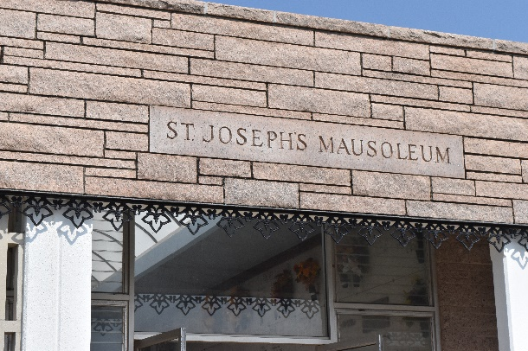

Mark Anthony Schexnayder passed away on Wednesday, October 2, 2024 at the age of 64. He was born in Lutcher, LA and a resident of Maurepas, LA.
Beloved husband of Melissa “Missi” Lindley Schexnayder. Loving father of Jenna Duhe (Stephen), Jessica Schexnayder, Maggie Schexnayder, Brittany Forman (Christopher), and Tyler Robinson (Amber). The Best Pappy to Alec Duhe, Cohen Beasley, Jonathan Mena, Grayson Forman, Mavery Forman, and Steele Forman. Son of the late Nelson and Rose Schexnayder. Brother of Joann Boudreaux (Bobby), Nelson Schexnayder, Wanda Taylor (Otis), Lisa Duhe (the late Perry), and the late Darren Schexnayder. Uncle of the late Colby and Kade Boudreaux. Also survived by other numerous nieces, nephews, and cousins.
Mark loved his family more than anything and prioritized spending time with them over any of his hobbies. He was a sincere friend too many and never met a stranger. He was a selfless and reliable person who always put other’s needs and wants, before his own. Mark was loved by many, and enjoyed making memories with his family and friends. He proudly served in the Army National Guard. He had a strong work ethic and worked as a process operator in the chemical industry for over 30 years. He was an avid outdoorsman who enjoyed hunting, fishing, and cooking in his spare time.
Relatives and friends are invited to attend the Visitation and Funeral Mass at St. Joseph Catholic Church, 2130 Rectory St., Paulina on Tuesday, October 8, 2024. Visitation will be held at the church from 9:00 a.m. to 11:00 a.m. followed by a Funeral Mass at 11:00 a.m.
Rose Lynn Funeral Home, Lutcher, Louisiana
October 6, 2024

