Dr. Barbara Terry Thompson

September 9, 1955 – November 27, 2007

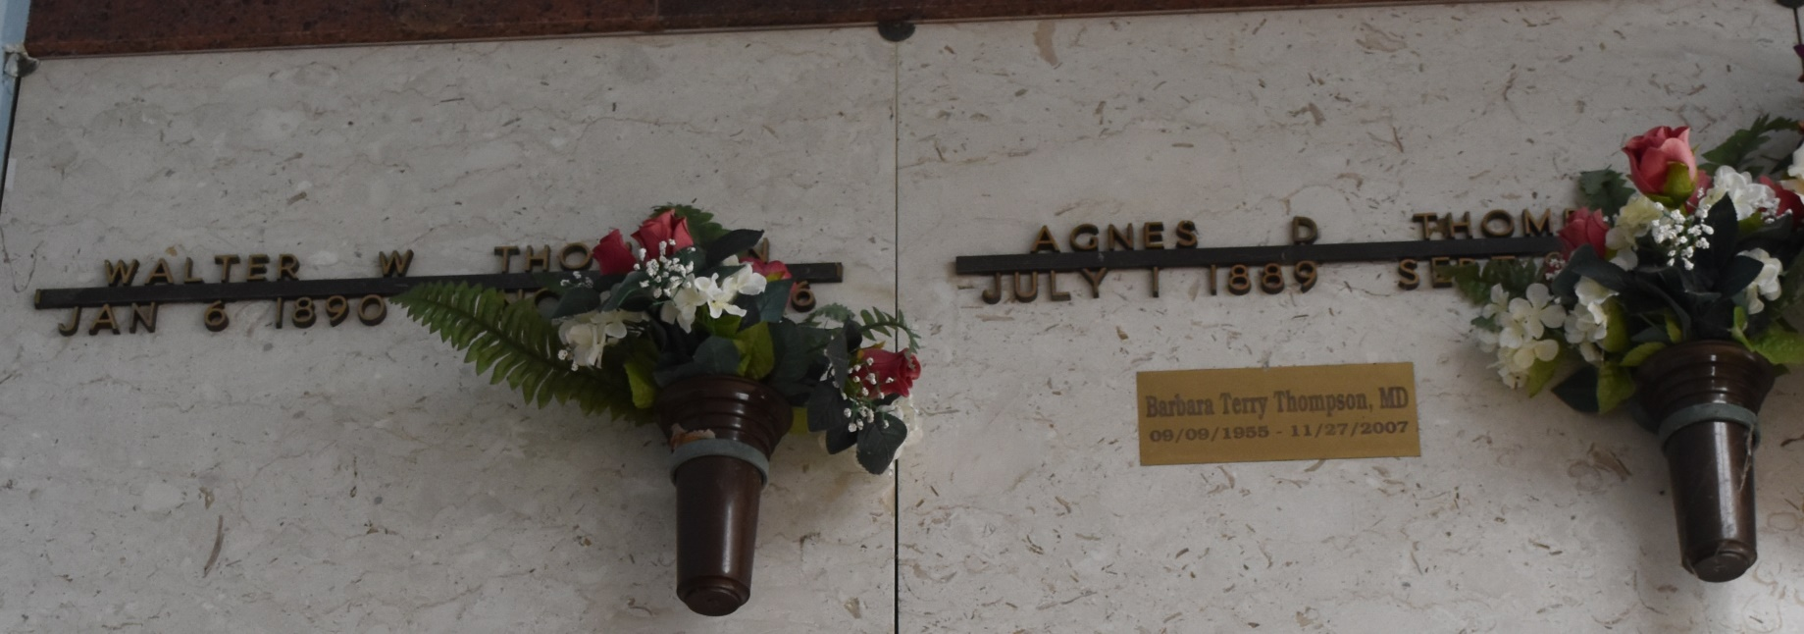

THOMPSON Memorial Services for Barbara Terry Thompson, M. D. of Columbia, LA will be held at 10:00 a.m., Saturday, December 8, 2007 from the chapel of Riser Funeral Home in Columbia. Visitation will be from 9:00 a.m. until time of services. Dr. Thompson died on Tuesday, November 27th, 2007 after a lengthy illness. Dr. Thompson was born on September 9, 1955.

She received her high school education at St. Joseph's Academy in Baton Rouge, LA and her BS degree from Loyola University in New Orleans. She received her MS degree from LSU in Baton Rouge and her MD degree from LSU in Shreveport. Dr. Thompson practiced medicine in Columbia, Louisiana and had practiced medicine since 1984. She served on several medical directorships, including, Citizens Medical Center, having previously served as Chief of Staff, Interventions, Inc., Haven Nursing Center, Mary Anna Nursing Home, Columbia State School, Caldwell Parish Ambulance Service, Northeast LA Ambulance Service, Hospice Care Foundation, Moss Home Health and Ouachita Vocational Technical Institute EMT Training Courses. Dr. Thompson was also, a charter member of the Chamber of Commerce in Columbia where she served as a member of the Board of Directors, was past Parish Council President and a member of the Finance Committee of St. John's Catholic Church, a member of the Historic Preservation Commission, a member of the Board of Directors and past President of the Schepis Museum Foundation, a member of the Board of Directors of the Main Street Program, a member of the Board of Directors of Caldwell Parish 911 system, a member of the Riverside Concert Band and a member of the Krewe of Iris in New Orleans, LA. Her awards included Louisiana Main Street Program Volunteer of the Year Award, nominee for the Northeast LA Arts Council Volunteer of the Year and Queen of the Mardi Gras Ball for the Krewe of Iris in New Orleans, LA.

She is survived by her parents, Leonard "Tommy" and Barbara Thompson of River Ridge, LA; her sister and brother-in-law, Margaret "Peggy" and Ray "Chip" Robert of Paulina, LA; her niece and nephew, Sarah Robert and Gary Robert of Paulina, LA; her aunts and uncles, Pat and Chuck O'Drobinak of Indianapolis, IN and Fred Terry of Hammond, LA; and cousins in Louisiana, Indiana, and Japan. Dr. Thompson was preceded in death by her grandparents, Fred and Alice Terry of Hammond, LA. Any planned memorials made be made to the Terry Thompson Memorial Fund account at Caldwell Bank and Trust Co. to assist with Dr. Thompson's medical expenses.

Published by The Times-Picayune (New Orleans, LA) on Dec. 8, 2007.