Drusilla (Schexnayder) Trosclair-Carbo

April 2, 1927 – June 24, 2018

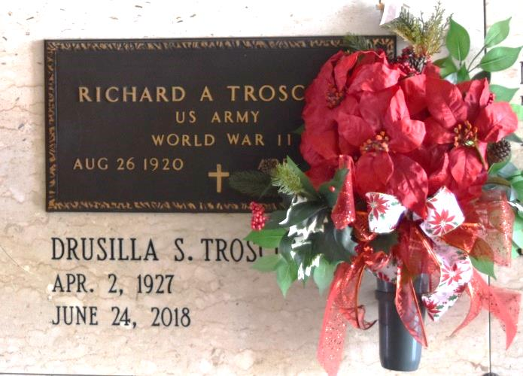

Drusilla Trosclair Carbo, age 91, passed away on June 24, 2018 in Lutcher, LA. She was a native of Paulina, LA. She is survived by her daughters, Catherine "Kitty" Snyder (Bobby) and Rachel Vicknair (George); sons, Richard "Ricky" Trosclair, Jr. (Mel) and Craig Trosclair; grandchildren, Kelly, Robbie, Courtney, Brittany, Stephanie, Ritchie, Ashley, and Chloe; great-grandchildren, Joshua, Jayden, Jordan, Collyn, Cale, Cohen, Kenzie, Quinn, and Ezra; step-children, Gaylynn Ford (Michael), Greta Morvant (Terry), Gwen Parfait (Pierre), and Gina Collura (Bennie); numerous step-grandchildren, step-great grandchildren, and step-great-great-grandchildren; sisters, Joyce Diez, Kathleen Summers, Frances Perret, and Diane Tramonte; brothers, Lionel and Tommy Schexnayder.

She is preceded in death by her husbands, Richard Trosclair, Sr. and Lawless Carbo; parents, Lionel and Agnes Schexnayder; sisters, Dorinna Schexnayder and Joan Trosclair.

A visitation in her honor will be held on Thursday, June 28, 2018 from 9:00 am to 11:00 am at St. Joseph Catholic Church in Paulina, LA followed by a Mass of Christian Burial. ROSE LYNN FUNERAL HOME SERVICES, 1870 Cabanose Ave., Lutcher, LA is in charge of the arrangements. To sign and view the family guestbook, please visit [www.roselynnfuneralhome.com.](http://www.roselynnfuneralhome.com/)

Published by The New Orleans Advocate (LA) from Jun. 25 to Jun. 28, 2018.