Gina Marie Troxclair
April 8, 1970 - August 23, 1982
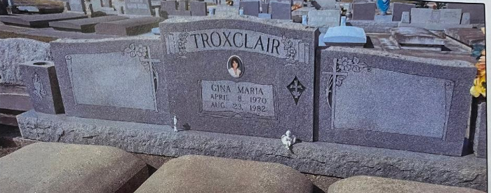

TROXCLAIR
Gina Marie Troxclair on Monday, Monday August 23, 1982 at 4:40 a.m.
Beloved daughter of James and Gloria Troxclair, sister of Gay T. Foret, Danna Ann and Angie Clair Troxclair and the late James N. Troxclair Jr., also survived by grandparents Mr. and Mrs. Simon Troxclair, Mrs. Aline B. Mancuso and the late Mr. Carlo J. Mancuso Sr. Age 12, A native and resident of Grammercy (sic), Louisiana.
Relatives and friends of the family, also members of Junior Catholic Daughters, Girl Scout Troop 1097, Grammercy Girls Softball League, students and faculty of Chanel Inter-Parochial School are invited to attend the funeral services from the Alexander Funeral home, 107 Jefferson Hwy., Lutcher, Louisiana on Wednesday, August 25, 1982 at 10 o’clock a.m. Mass of Christian Burial Sacred Heart Catholic Church, Grammercy, Louisiana. Interment St. Joseph Cemetery, Paulina, Louisiana. Friends may call after 4 p.m. until 11 p.m. Tuesday, August 24, 1982 and from 8 a.m. until service time on Wednesday, August 25, 1982.
Unknown newspaper clipping

