Jean Eugene Troxclair Jr.
February 17, 1930 – August 27, 2024

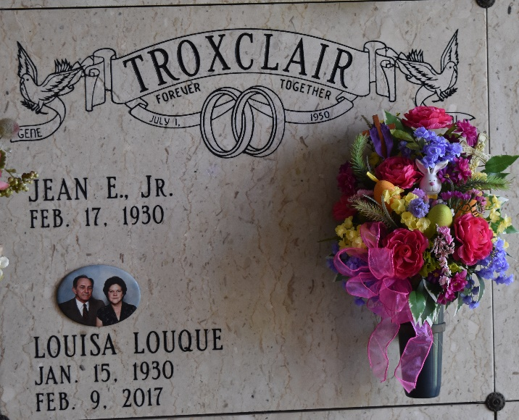

Jean Eugene Troxclair, Jr. passed away on Tuesday, August 27, 2024 at the age of 94. He was born in Garyville, LA and a resident of Lutcher, LA.
Beloved husband of the late Louisa “Gal” Louque Troxclair. Loving father of Denis Troxclair (Mary), Dionne T. Luminais (Toby), Tracey T. Tramonte (Lou) and the late Ward Troxclair. Grandfather of Jeremy, Jason, Joshua Troxclair, Jessica Thibodeaux, Michelle Meek, Wesley Troxclair, Travis Luminais, Sadie Politz, and Trina Trosclair, 15 great grandchildren and one great-great grandson. Son of the late Jean Eugene Troxclair, Sr. and Florence Torres Troxclair. Brother of the late Prudent “P.J.” Troxclair, Curtis Troxclair, Rose Mae T. Rouillier, Larry Troxclair, Beverly T. Willis and Harrison Troxclair. Also survived by a host of nieces and nephews.
Relatives and friends are invited to attend the Visitation and Funeral Mass at St. Joseph Catholic Church, 2130 Rectory St., Paulina on Saturday, August 31, 2024. Visitation will be held at the church from 8:00 a.m. to 10:00 a.m. followed by a Funeral Mass at 10:00 a.m. Interment in St. Joseph Cemetery, Paulina, LA.
Rose Lynn Funeral Home, Lutcher, Louisiana
August 30, 2024

