Bertha (Guidry) Vicknair

October 3, 1917 – August 15, 2006

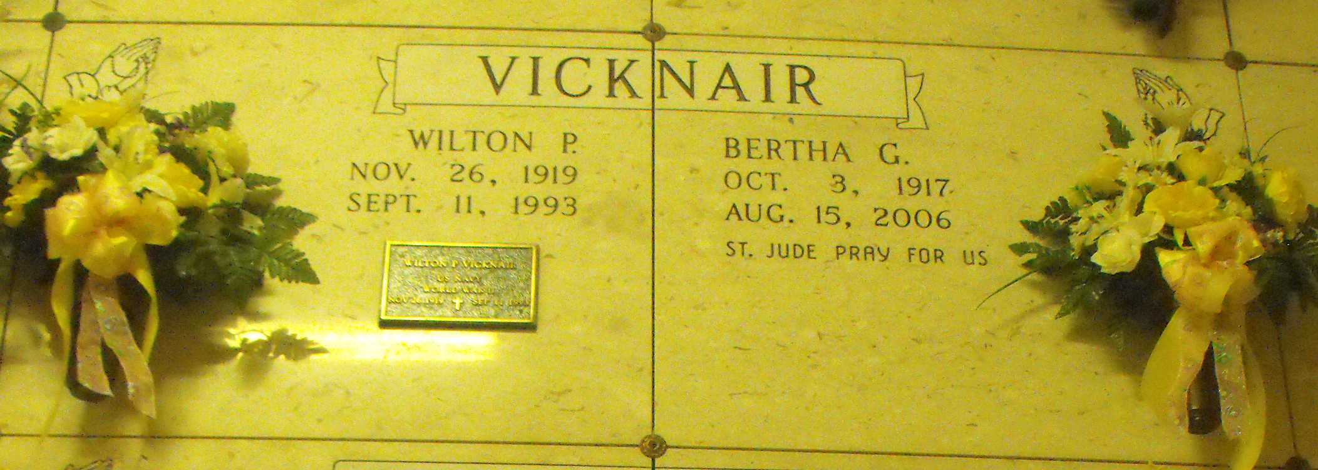

Photo by Mary Agnes Hammett

Vicknair, Bertha G. A retired homemaker and a resident of Lutcher, she died Tuesday, Aug. 15, 2006, at 5:45 p.m. in Lutcher. She was 88 and a native of Paulina. Visiting at Alexander Funeral Home in Lutcher on Thursday, Aug. 17, was from 6 p.m. to 9 p.m. Visiting resumes at the funeral home on Friday from 8 a.m. to 10:30 a.m. Mass of Christian Burial at St. Joseph Catholic Church in Paulina on Friday at 11 a.m., with the Rev. Frank Uter, celebrant. Entombment in the church mausoleum.  
  
She is survived by a daughter and son-in-law, Cheryll V. Phillips and Derek Phillips of Mobile, Ala.; son and daughter-in-law, Carl "Carlee" Vicknair and Peggy Vicknair of Lutcher; daughter-in-law, Donna Vicknair of Lutcher; three sisters, Buelah Hanle of Baytown, Texas, Elise St. Pierre of Paulina and Doris G. Vicknair of Gramercy; eight grandchildren and 11 great-grandchildren.  
  
Preceded in death by her husband, Wilton Paul Vicknair; son, Calvin Paul Vicknair; parents, Eugene J. Guidry Sr. and Leontine Matherne Guidry; two brothers, Numa Guidry and Eugene Guidry Jr.; and half brother, Oscar Oubre.  
  
She was a member of St. Joseph Catholic Church in Paulina and St. Anne Altar Society.  
  
Published in The Advocate (Baton Rouge, LA) from August 17 to August 18, 2006