Leonce Antoine Vicknair Jr.

October 28, 1885 – November 18, 1951

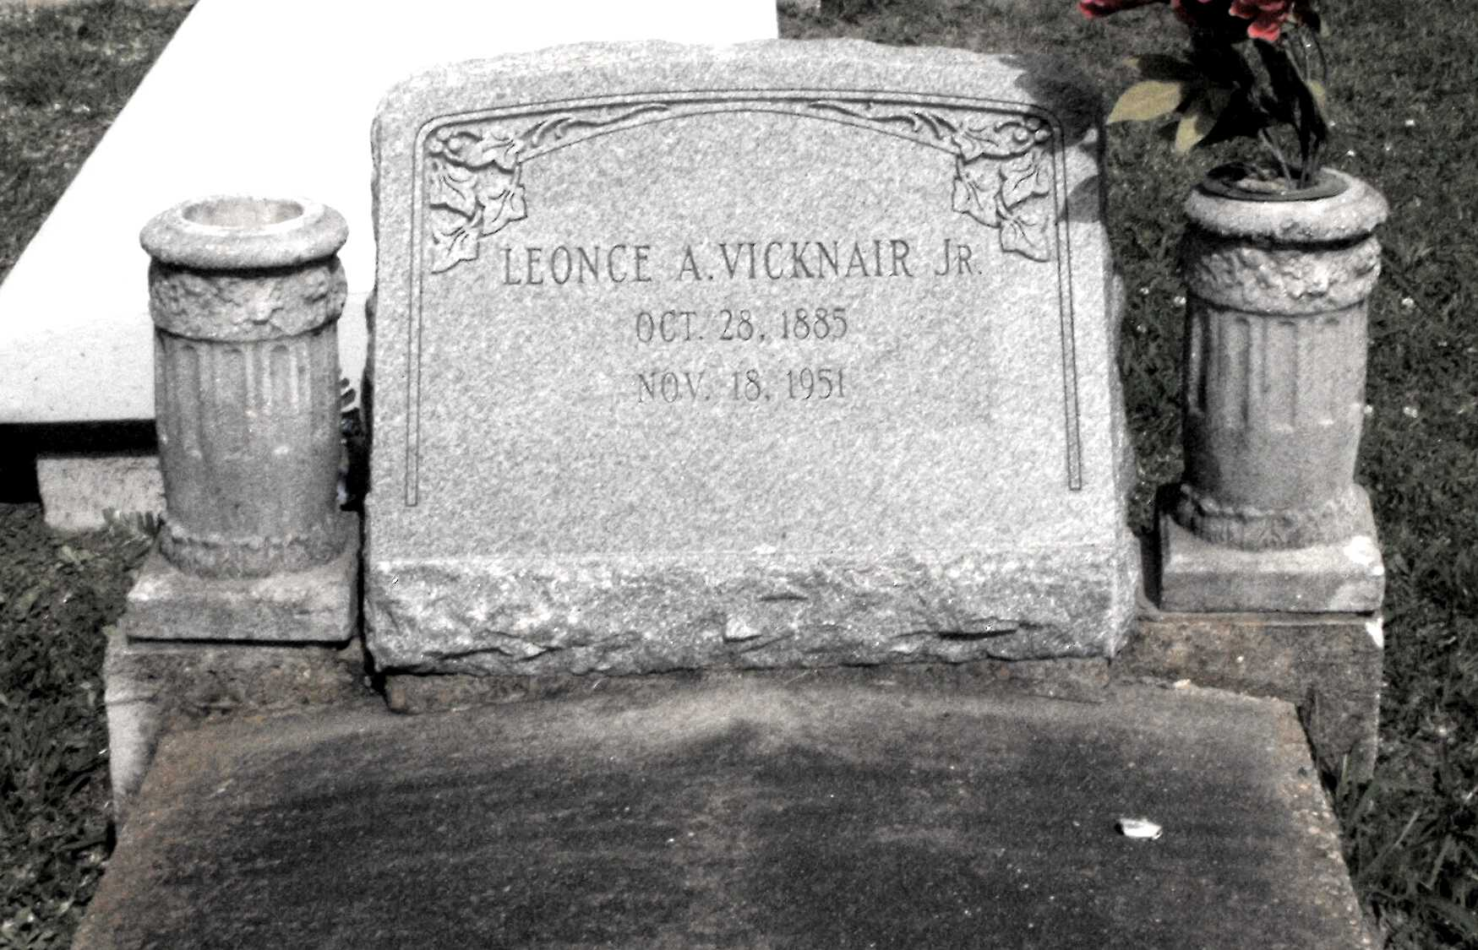

Photo by Mary Agnes Hammett

VICKNAIR - In Paulina, La, on Sunday, November 18, 1951, at 4:55 o'clock a.m., LEONCE VICKNAIR, husband of Aimee Guidry; father of Lawrence, Clovis, Albert, Earl and Leonce Vicknair, Mrs. Adlice Schexnayder, Mrs. Rose Mae Rome, Mrs. Linda Rouques and Mrs. Pearl Gaudet; also survived by 14 grandchildren; aged 66 years, a native and a resident of Paulina, La.

Relatives and friends of the family are invited to attend the funeral, which will take place from the Alexander funeral home, Lutcher, La, on Monday, November 19, 1951, at 9 o'clock a.m., followed by religious services at St Joseph's church, Paulina, La. Interment in St Joseph's cemetery, Paulina, La.

OBITUARY, The Times-Picayune, New Orleans, LA; 19 Nov 1951, p 2